# Using the NHS Learning Hub

The Learning Hub is a digital platform that provides easy access to a wide range of education and training resources for the health and care workforce, enabling users to search for and access resources.

Top Tip: Use ‘Chrome’ browser to get maximum benefit of the programme.

## Who is the Learning Hub for?

Individuals and organisations across the health and care sector, within the NHS, including local government and universities.

## Getting started

If you already have an account, go to the [NHS Learning Hub home page](https://learninghub.nhs.uk/), and log in.

If you don’t already have an account, go to the [NHS Learning Hub home page](https://learninghub.nhs.uk/), click ‘create new account’ and follow the instructions.

After registering you will receive an email that includes your username and a link to create a password.

There are two types of accounts:

* ‘General user account’ – users can access resources made available by contributors to all users. To set up a general user account you will need to provide an email address, the country you work in, and your current role.
* ‘Full user account’ - users can access all learning resources, contribute, and share knowledge and content. Additional information is needed to set up a full user account, such as a qualifying work email address (e.g. NHS email address)

For more information and support on who can access the Learning Hub please use the [Help Section](https://support.learninghub.nhs.uk/support/home)

## Finding our resources

You can access a variety of digital resources including eLearning, video, audio, images, documents, web links and articles that have been contributed by the health and care workforce.

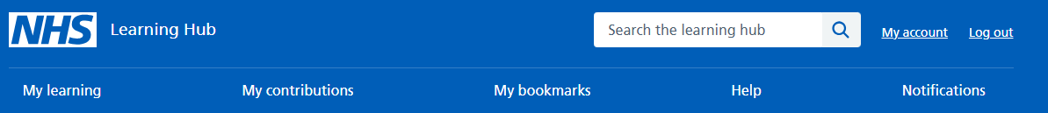

On the home page you can search the Learning Hub using the **search bar**.

**Tips**

* Single word searching will retrieve a lot of resources e.g., ‘social care’ (101 results).
* Try to be more specific in your search or if you know the exact name of the resource use that e.g., ‘Safe Management of Medicines for Social Care Staff’.
* When you have found what you’re looking for bookmark it for next time.