### Handling Medicines Safely for Adult Social Care Staff

### Do you need to know more about managing and administering medicines?

Try our Management and Administration of Medicines eLearning Modules which focus on the knowledge and skills necessary to handle and administer medicines safely. If you work in a health and social care environment, and support people with their medicines, either in their own home or in nursing or residential care settings, then you should find this e-learning useful.

Module 1: Introduction to Handling Medicines Safely

Module 2: Administering Medication

Module 3: Ordering, receiving, storing and disposal of medicines

Module 4: Understanding Medicines

These have been designed especially for you, so that you can access this learning free of charge, from any PC or device and get a certificate of achievement to show you have completed the training.

**Informal carers**

The e-learning modules have been designed primarily to support social care staff. However, informal carers (for example unpaid carers helping a family member, neighbour, or friend) should find Module 2: Administering Medication useful.

### Finding our resources

Here is a link to the catalogue where you can find the modules: [Safe Management of Medicines for Social Care Staff](https://learninghub.nhs.uk/catalogue/medsinsocialcare?nodeId=5594)

Once you are logged in, click on the **eLearning module link** to view and run the programme.

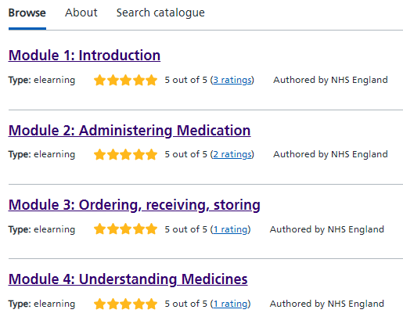

**OR**

From the [Learning Hub home page](https://learninghub.nhs.uk/) log in and use the search bar to search for the catalogue called

‘Safe Management of Medicines for Social Care Staff’.

### Ways to access the Learning Hub

This flyer provides information such as how to create an account: [How to use NHS Learning Hub](https://gbr01.safelinks.protection.outlook.com/?url=https%3A%2F%2Fwww.cdreporting.co.uk%2Fnhs%2Flatest%2Fpublic%2Fuploads%2FHow_to_use_NHS_Learning_Hub_v1.0.pdf&data=05%7C02%7Ckatherine.oloughlin%40nhs.net%7Cac44ab29d1294008db4208dce1410099%7C37c354b285b047f5b22207b48d774ee3%7C0%7C0%7C638632916501881124%7CUnknown%7CTWFpbGZsb3d8eyJWIjoiMC4wLjAwMDAiLCJQIjoiV2luMzIiLCJBTiI6Ik1haWwiLCJXVCI6Mn0%3D%7C0%7C%7C%7C&sdata=UWiyMpU5c4DubiANps%2FmkqH%2BIVknqY0P46qlWj2aBeg%3D&reserved=0)

Use the [Help Section](https://support.learninghub.nhs.uk/support/home) for support on who can access the Learning Hub and to find out how to access the Learning Hub by creating an account.

Top Tips:

* Use ‘Chrome’ browser to get maximum benefit of the programme.
* Don’t forget to bookmark it for next time!
* When learners get to the certificate page there is a link to a guide on how to save as a PDF and/or print their certificate. Once they have done this, they need to click the ‘next’ button (see image below) to also save the certificate to their ‘My Learning’ section of the hub.

