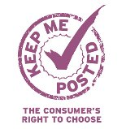
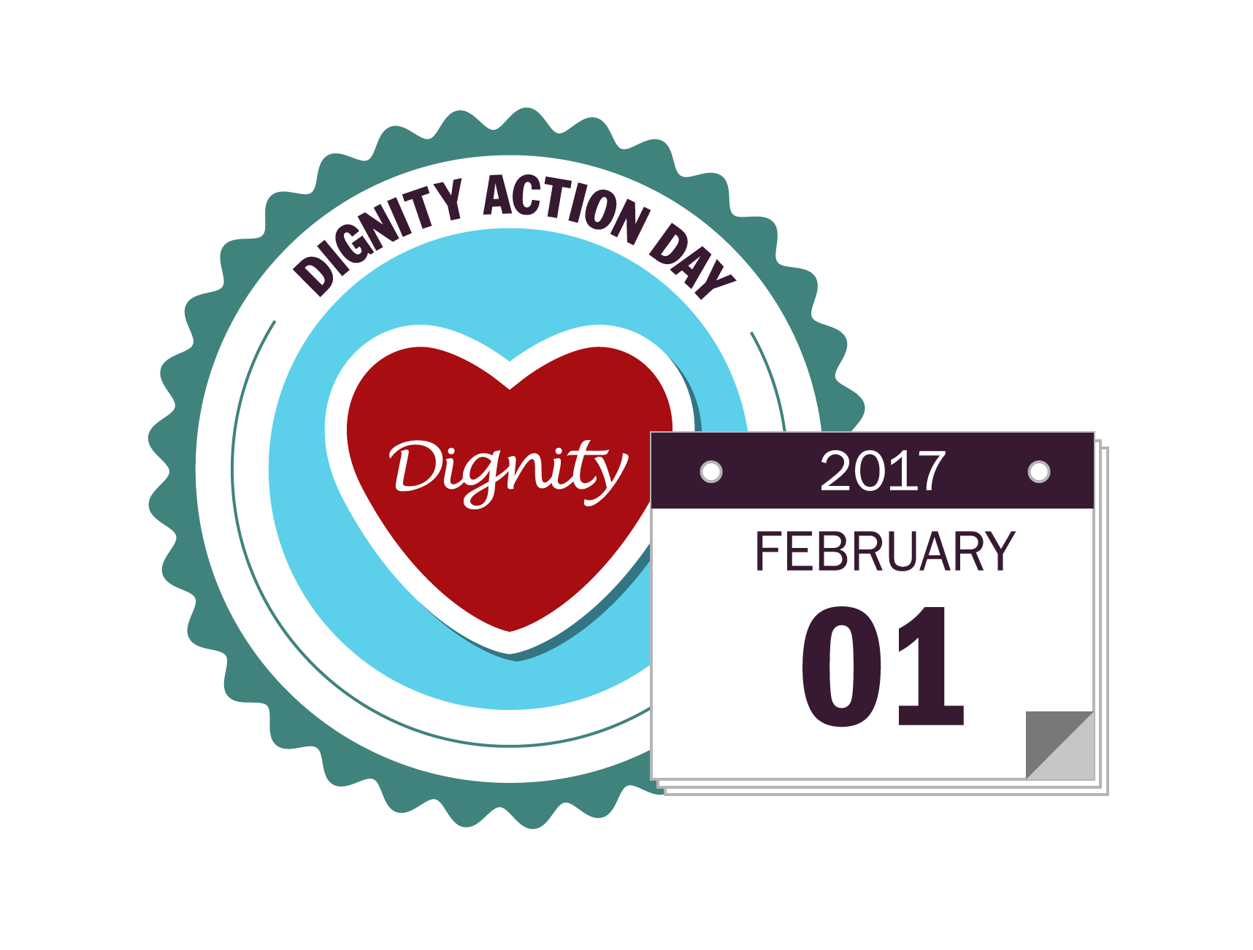

NATIONAL DIGNITY COUNCIL BACKS THE KEEP ME POSTED CAMPAIGN
- Keep Me Posted campaign welcomes its 95th supporter, National Dignity Council
- Jan Burns MBE, Chair of the National Dignity Council, said: “National Dignity Council is pleased to support the Keep Me Posted campaign so that people can get the information and advice they need in the format that is best for them.”

National Dignity Council/ Dignity in Care has pledged its support for the Keep Me Posted campaign ahead of the organisation’s annual Dignity Action Day on 1st February.

The charity, which is led by the National Dignity Council, aims to put dignity and respect at the heart of UK care services to enable a positive experience of care. The organisation has over 83,000 registered Dignity Champions who work to ensure people have a good experience of care when they need it. They include councillors, staff at all levels in NHS and social care, volunteers, service users, their carers and members of the public.

National Dignity Council is the 95th supporter to join the Keep Me Posted campaign. The campaign calls on service providers, including financial services providers, utility companies and telecoms providers, to give their customers a choice in how they are communicated with and provide them with the option of receiving bills and statements on paper. It is made up of a coalition of businesses, consumer interest groups and charities, including Age UK and MIND.

Jan Burns MBE, Chair of the National Dignity Council, said: “People who are being cared for want a choice about how they communicate, receive information and engage with service providers such as banks and utility companies. While online communication can be helpful, it can present a challenge for carers who are taking responsibility for others. National Dignity Council is pleased to support the Keep Me Posted campaign so that people can get the information and advice they need in the format that is best for them.”

Judith Donovan CBE, Chair of the Keep Me Posted campaign, said: “National Dignity Council campaigns to ensure that those who are receiving care are looked after with dignity. If the choice to receive paper-statements is removed it can result in distress for both the carer and the person being looked after, particularly when it comes to ensuring that finances are in order. I hear concerns from people of all ages, and industries, about the move to paperless bills and statements so I am pleased to welcome National Dignity Council as supporters of the Keep Me Posted campaign.”

- Ends –

Notes to editors
About the campaign:
The Keep Me Posted campaign is chaired by Judith Donovan CBE and is a partnership of representatives from 94 concerned organisations such as mental health charity Mind, DementiaUK, The Money Charity, and the National Consumer Federation.

Keep Me Posted campaign partners believe that it is every consumer’s right to choose, without disadvantage, how they are contacted by banks, utility companies and other service providers in the face of an increasing trend of businesses switching their customers to mainly digital communication, which isn’t always preferable or suitable for a large proportion of UK consumers.

