Dignity in Care Summer 2009

Welcome to this newsletter on work that is happening across UCLH, aimed at raising the profile of the importance of ensuring DIGNITY IN CARE for all patients accessing our Trust. To expect to be treated with dignity and respect is a fundamental human right and is core both to care and the services we provide across our organisation. Our Service Commitment highlights the importance of dignity and the need for all staff to both be aware and actively engaged in ensuring that patients are treated in a dignified manner.

We know how important patients rate dignity as part of their overall experience of care and services within our Trust; this has been highlighted in our recent national Inpatient Survey. For those of you who are ‘Dignity Champions’ I would like to congratulate you on your work to date, and to urge you to continue ‘flying the flag’ for dignity, for those of you who have not been involved with this work I would strongly encourage you to become so.

Sharing our successes is really important, however recognising and addressing the challenges too. Across our Trust there are a number of champions who are ready and able to support you in your work, I too am always happy to hear from you, if you wish to share your successes stories along with some of the challenges you face and need help in addressing.

Ensuring dignity is core to both our roles working within healthcare and how we work as a Trust, as Chief Nurse I would urge you to seize and drive forward this agenda!
Louise Boden, Chief Nurse

WHAT DOES DIGNITY MEAN TO YOU?

Different people have tried to define dignity, however what becomes clear is that ‘dignity’ means different things to different people. However, we know that ‘dignity’ is central to how patients both experience and judge the services that we provide. The Royal College of Nursing defines dignity as being:

‘…concerned with how people feel, think and behave in relation to the worth or value of themselves and others. To treat someone with dignity is to treat them as a being of worth, in a way that is respectful of them as valued individuals’.
RCN, 2008, Defending Dignity – Challenges and Opportunities for Nursing

Core to understanding what is meant by dignity is the fundamental human right that everyone should expect to be treated with dignity and respect.

DIGNITY IN CARE GROUP

The Dignity in Care Group meets bi monthly at different locations in the Trust. The group’s role is to coordinate and lead specific programmes of development Trust wide the aim being to both raise the profile of the importance of dignity in care and enable programmes of practice development aimed at improving patients experience of care.

For more information contact: Sam Philpott, Acting Divisional Senior Nurse (Emergency Services), Ellie Higgins, Divisional Senior Nurse (HH), Gillan Johnson, Lead CPF (NHNN) or Jonathan Webster, Consultant Nurse, Older People

DIGNITY CHAMPIONS - Do you know who your Dignity Champion is?

In November 2008, over 50 members of staff from UCLH took part in the launch of the Dignity Champion role in the Trust. A one day workshop was held for all the Dignity Champions from a variety of different areas. Speakers at the workshop included Deborah Sturdy, Nurse Advisor for Older People at the Department of Health, Louise Boden, Chief Nurse at UCLH and Pauline Ford, Nurse Advisor for Older People at the RCN and Dignity Lead. During the afternoon Pauline Ford facilitated a session using the RCN DvD ‘Delivering dignified Care: a Practice Support Pack for Workshop Facilitators.’ All of the Dignity Champions were supplied with a copy of the DVD and were asked to take it back to their work settings to use with their teams. A further ½ day workshops was run for Dignity Champions in June and a follow-up will be held in November 2009.

For more information contact: Jonathan Webster, Consultant Nurse, Older People or Claire Willis, Patient & Public Involvement Facilitator & Service Commitment Coordinator.

Links to the RCN, ‘Dignity at the Heart of Everything we do’ campaign: www.rcn.org.uk/newsevents/campaigns/dignity

DOH, Dignity Champion network
www.dh.gov.uk/en/Social Care/... /Dignityincare/DH 6600

IMPROVING NUTRITION FOR OLDER PEOPLE IN HOSPITAL

During 2006 Age Concern launched its ‘Hungry to be Heard’ campaign that aimed to raise the profile of the importance of nutrition in hospital. Recognising the importance of this, an audit tool was developed and piloted on the Acute Admissions Unit at UCH the aim being to audit against ‘The Seven Steps to Preventing Malnutrition in Hospital’. Following this audit it is planned that the tool be re-tested on T10, however in addition using Patient Stories as part of the audit process.

For more information contact: Acting Sister Rebecca Maud or Junior Sister Maddie McMillan.

Links to Age Concern, Hungry to be Heard Campaign: www.ageconcern.org.uk/AgeConcern/hungry2bheard.asp

Related publication: Maud R, Webster J, 2009, Improving Nutrition for Older People in Hospital by Assessing Current Practice, Nursing Times, Vol 105, No 5, pp 18-19

Eloise Horgan is a staff nurse in the critical care unit at the Heart Hospital. When she qualified Eloise began her career on the 4th floor at the Heart and when she was 3 months qualified she volunteered to take part in the creative arts project which was funded by the Foundation of Nursing Studies and supported by Age Concern Islington. The project brought 8 nurses and 8 older people together to explore dignity in care using the creative arts. Eloise felt it was a good starting point for her career following 3 years of intense study as a student. The focus upon essential principles of nursing care and the unusual idea of learning with older people was intriguing.
Reflections of a Dignity Champion

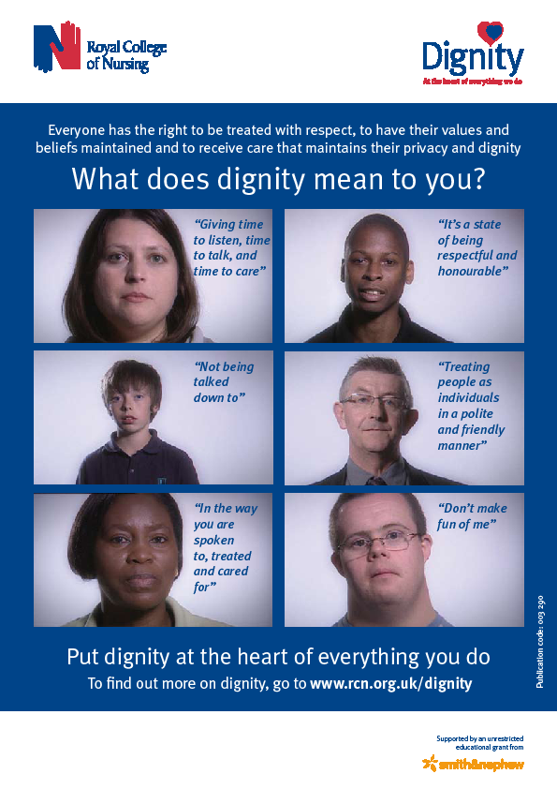Eloise had not experienced undignified care throughout her training therefore the initial discussions with the older people were an eye opener about how a lack of communication from nursing staff can affect the patient experience. For example nurses appearing to be so busy that patient’s felt unable to approach them for their basic needs.

Following the programme Eloise and her colleague did a notice board for the 4th floor to raise awareness of dignity issues. The ward staff started to ask questions and Eloise and her colleague linked this into the changes to the NMC code of conduct which emphasises the responsibilities of the nurse in relation to dignity. Practical aspects of care such as ensuring curtains were able to close properly and protected mealtimes were also highlighted to the catering and nursing teams. The work also helped the teams to understand the importance of the red menus and gender separation and contributed to more involvement from the multi-disciplinary team in ensuring that the individual needs of the patients are met to a high standard.

Following the evaluation of the creative arts project Eloise was asked if she would attend and co present the project at an International Practice Development Conference in The Netherlands. As an innovative idea the creative arts project was very well received at the conference and by sharing her experience the delegates went away with more ideas on how to improve the patients experience in relation to dignity.

On a personal level Eloise recognises that becoming involved has helped her to build confidence in communication as a junior staff nurse and she has belief in herself that she can influence a change in practice. In addition Eloise feels her involvement with the dignity project has given her the confidence to make a career choice to move to the critical care unit.

For further details on the project please access the link:
http://www.fons.org/ns_projects.asp

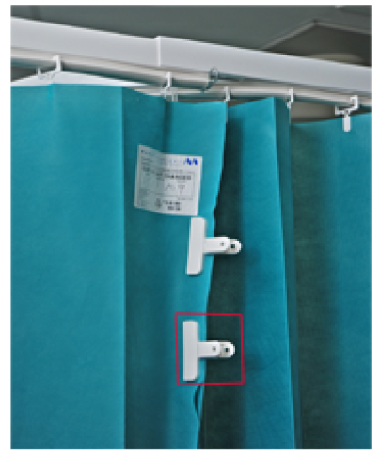

Using curtain clips on ACW,
2nd Floor, Heart Hospital.

For more information, please contact Nicola Clark on Ext 9084
Promoting Curtain Clips
For more information please contact Nicola Clark on Ext 9084

The purpose of curtain clips and do not disturb signs is to make busy staff 'stop and think' before entering areas where care is being carried out with patients.

Discovery Interview
Understanding what is meant by dignity and how patients experience dignity is complex and requires approaches that enable patients to share their experiences. A programme of practice development, funded by the Foundation of Nursing Studies is being led by Jonathan Webster (Consultant Nurse, Older People) and staff at the NHNN using “Discovery Interviews” (DI). DI’s are being used as part of a programme of practice development, which aims to use interviews to explore and improve aspects of dignity in care for older people. It is one-to-one, face-to-face semi-structured interviews conducted by health service staff, trained in the technique that focuses on individuals telling their stories of care in their own words.

The questions being asked are:

- What experiences of hospital care do older patients and their relatives describe?

- What do older people and their relatives understand by the term 'dignity'

- What aspects of service provision do older people and their relatives identify as significant influences on the quality of their experience, and on perceived level of dignity in care?

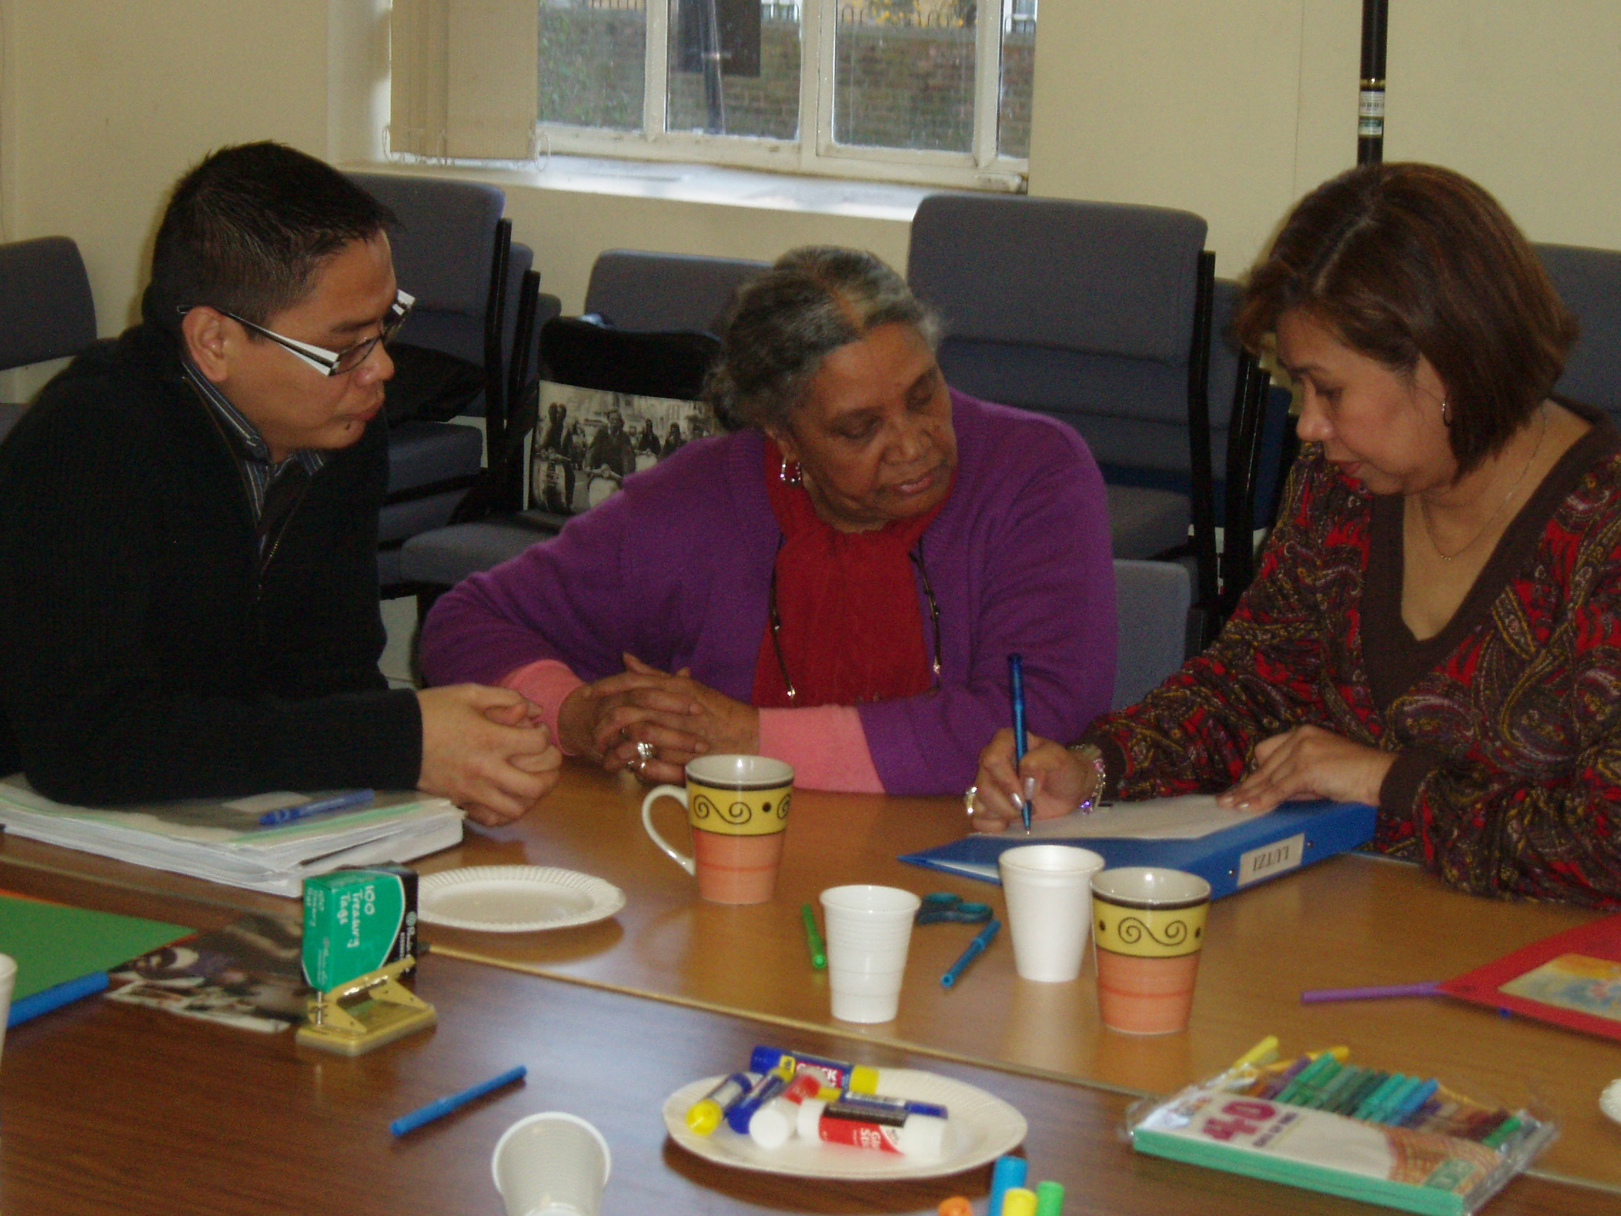
Once completed, interviews are transcribed and are then shared with and therefore, owned by the multi-disciplinary team to help develop a clearer understanding of dignity in care, and prompt realistic action planning to improve the patients’ experience of care in hospital.

For more information contact:

Gillian Johnson, Lead CPF, NHNN

Vicky Dunne, Ward Sister, Albany Rehabilitation Unit, NHNN

Sue Humbleston, Occupational Therapist, Hughling Jackson Ward, NHNN

Dignity Web Site

The Dignity in Care pages on Insight are ‘under construction’!


The new pages will be easier to navigate and display relevant documents to support the dignity in care work streams and dignity champions.

It is important that Dignity Champions and staff working on the Dignity agenda are part of a community and the web site will facilitate this:

- All dignity champions and dignity in care group members will be listed under the contacts section to facilitate networking.

- Dignity in Care meeting minutes and dates will be available for all to see and keep up to date with what is being done across the Trust to promote the Dignity agenda. All dignity champions and other staff interested in dignity are welcome to join these meetings.

- Updates and documents on dignity projects such as the Creative Arts, Discovery Interviews and Dignity Champion workshop presentations will be available.

- Links to important websites such as the ‘RCN Dignity: At the heart of everything we do’ and the Department of Health Site will be posted on the site for easy access to all relevant information.

There will also be a link to the Service Commitment pages to tie in with UCLH wider agenda on improving quality and the patient experience.

The new site can be found under Insight > Projects > Dignity in Care
Watch this space!



Vicky Dunne Ward Sister at the NHNN has put together an initial draft of an observation of care tool to look at dignity on the ward. It is based on Essence of Care & the Dignity Benchmark. It is hoped that use of this tool will enable us to have a more structured approach to assessing weather dignity is prioritised in our places of work. It is hoped to identify 'best practice' & potentially new ways of working. It looks at 'Activities & Behaviours', 'Verbal Communication', 'Skill Attainment & Performance' & 'Environmental Characteristics'

Vicky is awaiting feedback from the rest of the group but hopefully we shall have a finalised, ready to use version soon.

Observations of Care Tool

Privacy and Dignity

Clinical benchmarking is well established across the Trust. The benchmark for Privacy and Dignity focuses on 7 key factors:
- Attitudes and behaviours
- Personal world and personal identity
Essence of Care
- Personal boundaries and space
- Communicating with staff and patients
- Privacy of patient-confidentiality of patient information
- Privacy, dignity and modesty
- Availability of an area for complete privacy.
All areas in the Trust are expected to complete clinical benchmarking. Do you know how well your area did for the Privacy and Dignity bench mark?
For more information about the Privacy and Dignity benchmark contact Ellie Higgins, Divisional Senior Nurse (HH)

Future Work

Maintaining a clear focus whist ensuring sustainability in programmes of work is key to the dignity agenda within the Trust focussed upon improving the patient’s ongoing experience of care and services.

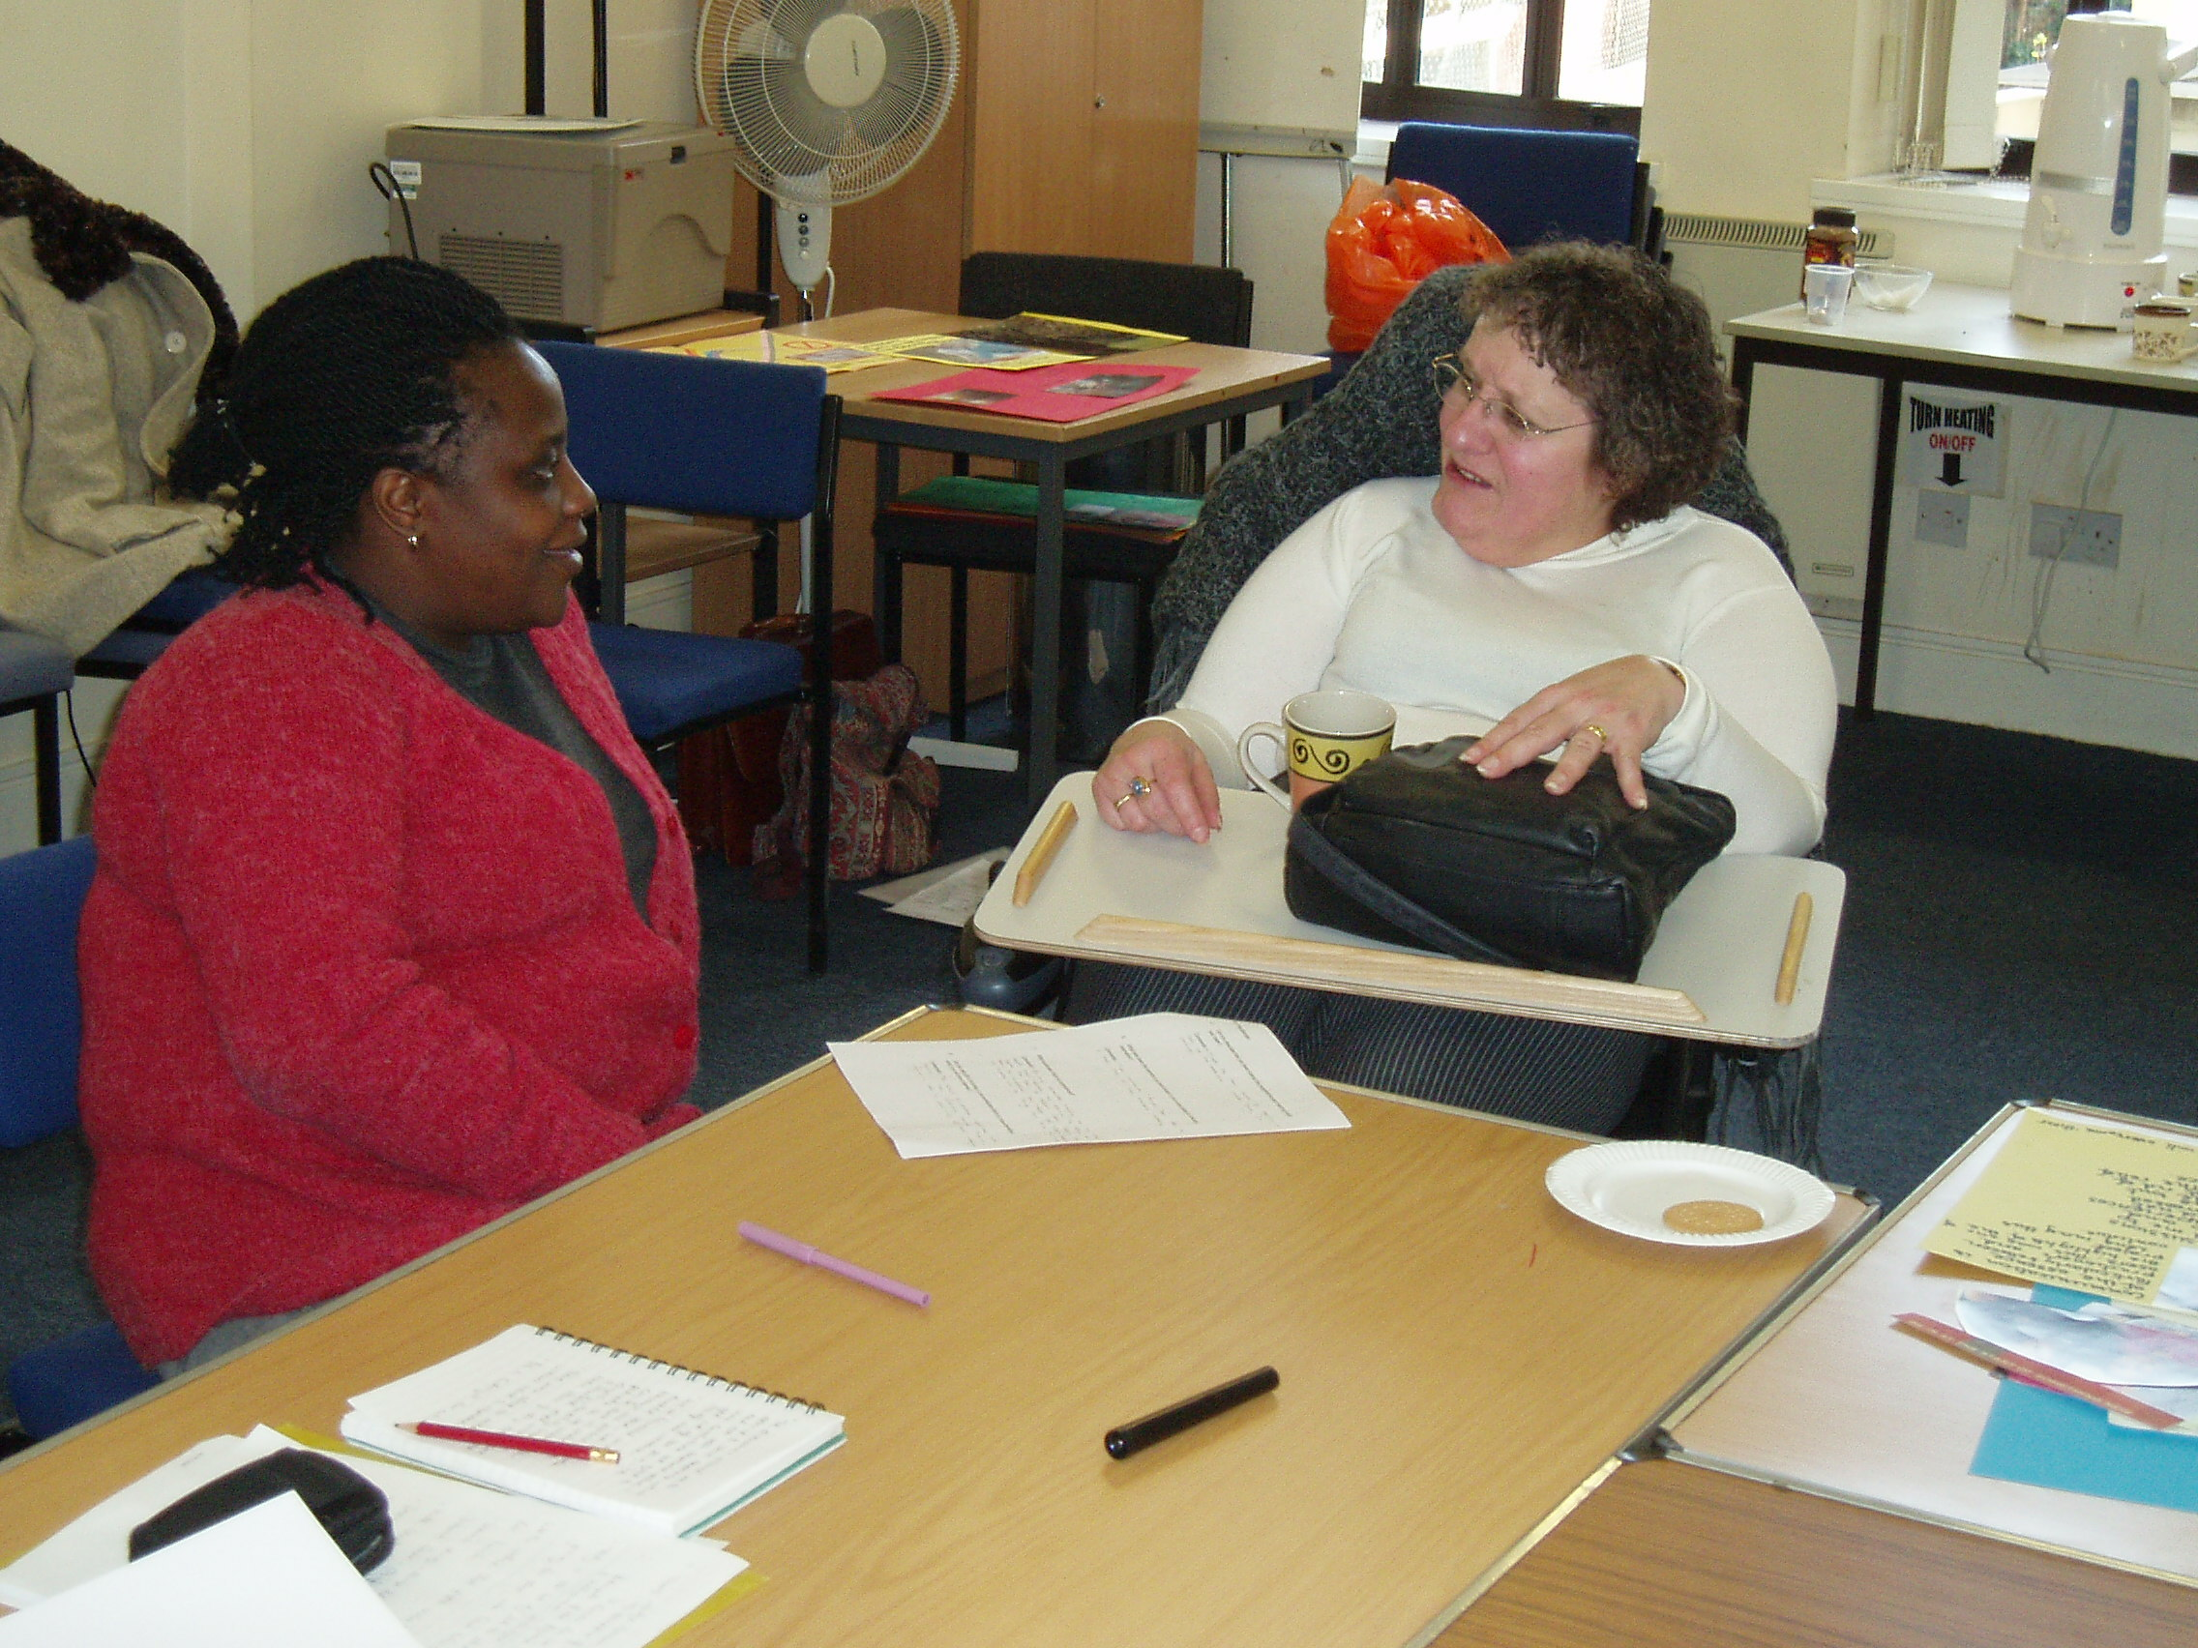
Future work will include:

- Ongoing support for Dignity Champions & developing ‘new’ Dignity Champions.

- Building upon programmes of practice development and roll-out to other areas.

- Ensuring that ‘dignity’ appears in all relevant training for staff Trust wide.

- To maintain and keep the dignity agenda ‘fresh’ and ‘reenergised’.

- To develop champions for dignity at all levels across the organisation

- To ensure that all programmes of work and development are focussed-upon working in collaboration with patients/ service users

Do you feel inspired to become a 'champion' for dignity?

If so, sign-up as a Dignity Champion with the Department of Health, look at resources available such as those produced by the RCN and the 'Lets Respect' campaign and join the UCLH Dignity in Care Group!

