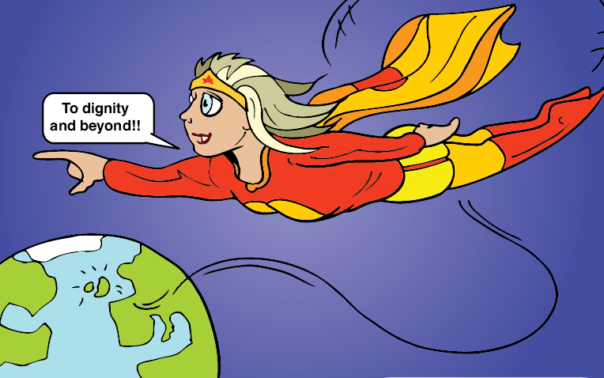
I'm a dignity champion
Are you?




Our badge / coaster template

Skills for Care West Midlands ensures that West Midlands Dignity Challenge activity is put on the map

Within Skills for Care West Midlands we are continuing to promote the Dignity challenge throughout the special care workforce in the region. We aim to promote the challenge at every meeting we hold or attend locally and regionally. Our Regional Development Manager, Jan Burns, has travelled far and wide as National Skills for Care lead to and even had an extremely successful trip to the Isle of Man to give a presentation.

We have produced a range of marketing materials including coasters, badges and bookmarks to promote our campaign to make every person working in social care in our
region a Dignity Champion. Through our 7 sub regional employer partnerships we are well placed to engage with over 3800 social care employers within the region and at least 150 training provider organisations, not to mention over 200 members of our West Midlands Alliance.

Dignity is a constant theme at our Alliance for Assessors, verifiers, mentors and training providers in health and social care. Up to 100 members of this group meet 4 times a year. Many of them have taken the challenge to sign up as individual champions, many have promoted the challenge to colleagues within their organisation, and more importantly many are now integrating ‘dignity’ into their curriculum or assessment practice as they work with a wide variety of learners.

In our last newsletter we appealed for readers to let us know about current work they have initiated following our challenge to them and we very quickly had over 25 responses. Some of these responses are detailed in our next newsletter due out shortly. The others will be placed on our website to help us to build up a regional map of ‘Dignity Hot Spots’. Here are just a few of the responses we have had following our small part in the campaign.

Spreading the word
Carol Law - Dudley Crossroads
I have to tell you that to implement the pledges made by me I have arranged a staff meeting where the dignity challenge was outlined to all staff. Each one was issued with a card giving details of how to sign up. I have also presented a report at a Trustees meeting on the dignity challenge and its importance and asked out trustees to sign up as well.

Making a difference in the little things – it doesn’t have to be a massive step to improve people’s experiences.

Pat Hulme - Woodlands Quaker Home & Sheltered Housing for Older People
I have challenged staff who worked from a list of ‘set’ bath times for residents.
I have changed this practice to empower residents to choose the time of day, day of the week and a choice of bath or shower.

“Small word with a massive meaning”

Mark Casey - Charted Care (West Midlands) Ltd
I am writing to inform you of the ways I have promoted the dignity in all aspects of my working and daily life, firstly in my work environment while I have been conducting staff supervision with the care workers I have brought up the subject of dignity and got quite a lot of blank looks and silences. The way I put it over to the care workers was that it was such a small word with a massive meaning and impact on how you treat other people not just work colleagues or service user but family, Joe Bloggs in the street, everybody and everything! I am also setting up a short training session for all care workers and then using it as part of the skills for care induction program.

Challenging disrespectful and inappropriate behaviour
Julie Hill - Age Concern Training
I have recently completed a dignity postcard and now I am implementing these pledges. I work for Age Concern Training, as an equality and diversity ambassador for Age Concern Training. It is my main priority to promote Equality and Diversity, Rights and Dignity to all learners. Role modelling good practice to enhance performance within the social care environment. It is essential that during training our codes of practice are adhered to raising awareness and challenge disrespectful and inappropriate behaviour.

