Dignity in Care Activity in Trafford

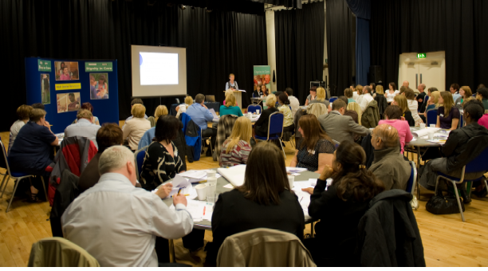
Trafford Adult Social Services

Dignity in Care - Providers
As part of our ongoing campaign to promote Dignity in Care, Trafford Adult Social Care Directorate held a large consultation event on Dignity with our provider services. The event was attended by 70 representatives from both externally commissioned and in house services across all service areas.

Building on the Dignity Champions work already underway in Trafford, the aim of the event was to explore with social care service providers how they actually embed Dignity into their day to day work. Anna Gaughan, the North West Dignity lead spoke to the group about the Regional and National agenda around Dignity, the links with Safeguarding Vulnerable Adults , the importance of Partnership Working in terms of embedding Dignity into commissioning outcomes but also identified examples of best practice and the support available.

A focus of the workshops was to ask participants to explore what dignity in care means, what you can expect to “see” and “hear” when dignity is integrated into practice. Opinion was also canvassed as to what support attendees wanted from the council and identified a group of providers who wanted to work with Trafford on this agenda with the hope of establishing a Dignity in Care Award.

Feedback from the day will contribute to developing benchmarking standards around dignity which can be built into commissioning and Quality Assurance processes but also hopefully to develop a Dignity in Care award using Lay Assessors as part of the assessment process.

Discussions are already in progress with our Health Partners as to how this important joint agenda can be taken forward together and further events anticipated supported by a publicity campaign.
Dignity in Care Forum Established
Participants at the Provider Consultation event who signed up to take part in developing Dignity in Care in Trafford were invited to join a Forum 2 months later which was also attended by service user and carers representatives, Commissioners, Communications, the Safeguarding Team and the Learning and Development service.
The group is keen for good practice to be shared across the Trafford economy and discussed ways of developing criteria and assessment methods for a Trafford award as well as the development of a newsletter, information materials for staff and the expansion of the forum to include other Trafford sectors.
Trafford’s Dignity in Care campaign will place great emphasis on improving the quality of care and the experience of citizens using services including community services, care homes, home support services and NHS hospitals.
Commissioners have now included Dignity in Care in Commissioning Strategies.
A small sub-group of the Forum will work on establishing a Dignity Award.
Discussions with health partners have brought the possibility of Trafford Economy-wide Dignity in Care Event.

Dignity in Care – Awareness Raising for Service Users, Carers and Families
A Drama Day in July used powerful drama productions to explore a range of issues, including Dignity in Care, Safeguarding Vulnerable Adults and the Mental Capacity Act Deprivation of Liberty Safeguards. Facilitated workshops captured the views and comments of carers, families and service users and Graham Ogilvy’s drawings highlighted issues that arose during discussions.

Dignity in Care – Tackling Age Discrimination
Providers have reported satisfaction with the work of employees who are over retirement age.
A home care provider wrote an account of their mediation between a woman aged 90 and a man who was seeking to dominate her care provision. [See attached “Defending Rights of Older Service User’]
A local Church held a week of events to highlight the contribution that older people can make to society. [See attached “Young at Heart Week_August 2009”]
Age Concern reports on a project to train older people to use the internet and to train their peer group. [See attached “Silver Surfers Project August 2009]

