Sterling Care and Support

25 February 2010

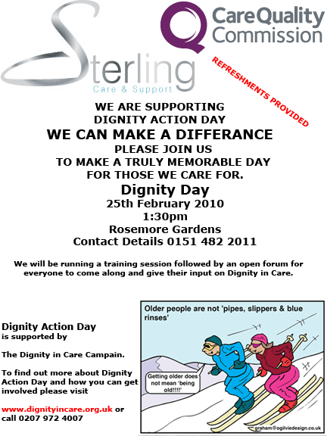
We understand that self respect is a key ingredient to living a full and meaningful life and without dignity and resepect for diversity there can be no self respect. This is why we believe passionately that everyone has the right to be treated equally and respectfully. We believe we all have a responsibility to protect vulnerable people in order that they live the life THEY wish to live.

