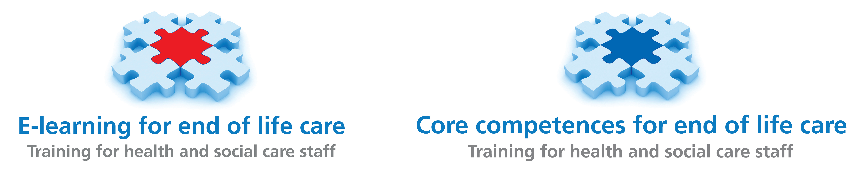

North East E-learning in End of Life Care for All (e-ELCA)
Launch Event
23rd March 2010
Venue – The Vermont Hotel Castle Garth, Newcastle upon Tyne, NE1 1RQ
Time | Session | Lead
9.30 Morning Session Registration Tea/coffee
10:00 | CHAIR  Welcome and introduction | TBC
10:10 | Update of Principles and Competences Phase 2 | TBC
10:40 | Keynote Speaker Introduction to e-ELCA | Dr Bee Wee Clinical Lead e-ELCA
11:20 | Demonstration of E-Learning tools  Q & A | Abdul Khaliq Nathekar & Shamir Gokani e-ELCA team / NLMS
11.45 Coffee / refreshments
12:00 - 13.00 | E-Learning Practical Session | Abdul Khaliq Nathekar & Shamir Gokani e-ELCA / NLMS
12.30 Afternoon Session Registration
13.00- 14.00 Lunch Morning and Afternoon Sessions
14:00 | CHAIR  Welcome and introduction | TBC
14:10 | Update of Principles and Competences Phase 2 | TBC
14:40 | Keynote Speaker Introduction to e-ELCA | Dr Bee Wee Clinical Lead e-ELCA
15:20 | Demonstration of E-Learning tools  Q & A | Abdul Khaliq Nathekar & Shamir Gokani e-ELCA / NLMS
15.45 Coffee / refreshments
16:00 | E-Learning Practical Session | Abdul Khaliq Nathekar & Shamir Gokani e-ELCA / NLMS
17.00 | END

