

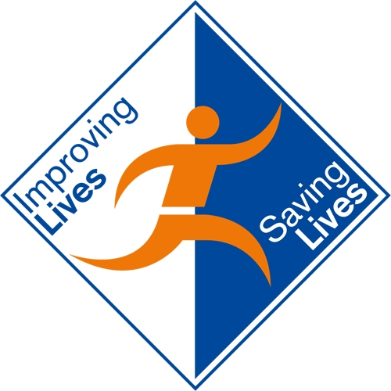
Person Centred Services
The Dignity in Care Challenge
3 February 2010 | Hilton Hotel, Stansted Airport

Agenda

08:45 Registration and refreshments
09:30 Welcome & Introduction to the day
Amanda Reynolds, Deputy Director, Social Care & Partnerships
Government Office for East of England
09:45 The Heart of Care
Amanda Waring
10:15 What does good look like? Lessons from Eastern Region’s study visit to
Sweden
Norwyn Cole, Regional Director, Care Quality Commission
Kristina Nilsson-Lindstrom, Head, Malmgarden Residental Centre
Kent Soderberg, Manager Malmgarden Residental Centre
Beverley Hallpike Nurse Consultant, NWMH NHS Foundation Trust
11:15 Refreshments & Networking
11:30 Workshop Session 1
- ‘You are words’: Hearing the Voices of Persons with Dementia Through
Poetry
John Killock, Poet & Researcher
Lynda Martin, Partnership Manager, Cambridgeshire Libraries
- Carers – Dignity & Respect for family carers is not rocket science
Jaqui Martin, CEO Suffolk Family Carers: Chair Regional Carers Board
Julia Hiley & Becca Winwood, Carers Experience Leads
- Our Privacy, Your Dignity - Delivering Same Sex Accommodation
Marion Collict, DSSA Manager, NHS East of England
12:30 Lunch & Networking
13:30 Workshop Session 2
- Achieving Dignity within End of Life Care
Penny Lavis, Programme Manager, NHS East of England
- Carers – Dignity & Respect for family carers is not rocket science
Jaqui Martin, CEO Suffolk Family Carers: Chair Regional Carers Board
Julia Hiley & Becca Winwood, Carers Experience Leads
c) What do you see? Look closer …see ME – Dignity in Dementia
Pol Toner, Head of Mental Health & Learning Disabilities, NHS East of England
14:30 From here to Dignity… exploring and advancing dignity in the EoE health
and social care system
Chris Birbeck, NHS East of England
15:30 How Dignity in Care supports Safeguarding & Quality in Adult Care
Penny Furness-Smith, Director of Adult Care, Luton Borough Council
15:50 Summing up
16:00 Close and Departure


