DIGNITY IN CARE

Department of Health

Big Ideas Project

Buckinghamshire

Service users’ views on their experience of Dignity in Care

November 2011

INDEX

Subject Page No
How the Project Started 3
The Bid 4
The Project Team 5
The Process 6
Principals 7
Issues Emerging 7
Practice Issues 8
Emerging Outcomes 9
Outcomes 9
Issues 10
Next Steps 11
Appendix 1 Interviewers Training Programme 13
Appendix 1A Notes for Interviewers 16
Appendix 2 Letter to Service Managers 22
Appendix 3 Feedback Form 24
Appendix 4 2nd Letter to Managers 26
Appendix 5 Information Sheet for Service Users 27
Appendix 6 Service Users Consent Form 30
Appendix 7 Letter of Authorisation 31
Appendix 8 Analysis of interviews –pro forma 32
Appendix 9 Interview Analysis 34
Appendix 10 Breakdown of Project time and tasks 40

SUMMARY OF THE DEVELOPMENT OF THE DIGNITY IN CARE PROJECT IN BUCKINGHAMSHIRE
Part of the Department of Health initiative for Dignity in Care
Aim of project: To improve practice in respect of dignity in care by training older volunteers to interview older service users about the way they are treated and referring outcomes to the Commissioning and Contracts Managers for Bucks Adults Care Services in order to improve service provision.
Health Services were not included in this project but it is hoped to roll the model out through the Primary Care Trust and the Bucks Hospitals and Community Trust at a later stage.

How the project started:
We had a model from a previous project in Buckinghamshire in 2007 when older volunteers were trained to carry out interviews to find out patients’ experiences on being discharged from hospital This was a fully funded project through joint Commissioning and a management consultant was paid (c. £14,000) to project manage the process and analyse the findings from the interviews, and write a Report.
Originally it had been proposed that care workers (i.e. professionals) would carry out the interviews, but it was decided that older people who were not paid professionals would establish trust more readily. This proved to be the case.
In 2009 a team of volunteers was invited to be part of an evaluation carried out by Oxford Brookes University of a Bucks County Council initiative- the In Touch Service. This service provides pro-active telephone-based assessment, information, advice and signposting for adults who may be finding it difficult to maintain independence in the community. A review is offered and telephone support by a team of Age Concern volunteers. Our team of volunteers carried out friendly telephone interviews within a framework of questions agreed with the Research Team.
For the current project there was a grant from the Department of Health Dignity in Care Big Idea initiative which the Bucks proposal was successful in winning in 2010. This was for £2,000 to cover travel expenses, the purchase of hand held tape machines and some admin support in typing up tape recordings. It did not provide for any project management costs.
The project was located in a Dignity in Care sub-group within a Bucks Older People’s Champions Forum, which was accountable to a multi-agency Older People’s Partnership Board. It has subsequently been moved to sit under the Safeguarding Vulnerable Adults Board.
The project was suggested at a meeting between the Chairman of the Champions Board and the Commissioner for Adult Care Services and the Operations Manager in September 2009 as an initiative which could be launched as Bucks’ contribution to the national day of the elderly on the 1st October. The Chairman of the Champions Board had been part of the 2007 project but unfortunately was going away for a month immediately.
The Chairman of an Older People’s Forum which co-ordinates a network of Older people’s Action Groups in the County (also a member of the Dignity in Care sub-group, absent at the time from the meeting) was asked to take on the leadership of the project. She had not been involved in the 2007 project. She, with the Commissioner, agreed they would put together the bid. There was a very short run-in time with internet voting.

The Bid
The Bucks 50 Plus Forum, who have a number of OPAGs and affiliated groups across Buckinghamshire, make sure that the voices of the over 50's are heard and that they influence the way in which services are planned and delivered.
They would like to undertake a project to visit 34 health and social care services across Buckinghamshire during 2010 and 2011. The Forum would like £2000 grant to cover the volunteers training and travelling expenses etc.
The purpose of the visits will be to assess how well services are meeting the challenges of dignity in care and whether there are any issues which are preventing improvement in certain elements of the services.
They wish to promote good practice in the dignity framework to bring service providers and the statutory authorities together in ensuring people are given respect and dignity throughout old age.
Carers Bucks have also agreed to ask their members if anyone would volunteer to visit one or a number of services to review the dignity in care agenda.
Bucks County Council have agreed to run a training session for all volunteers on lay assessment and to facilitate the volunteers in developing a standard assessment document.
The bid was successful and the Commissioner agreed to take on the project management role using her P.A. for the administration. Unfortunately neither she nor her P.A. were allocated dedicated time to the Project.
Since they were in the employ of Social Services they largely had their own agenda to evaluate the care provided in Care Homes. Pressed for time, assessment documents to be used as tools in the Big Idea Project were modified from Inspection programmes, and were not actually appropriate for our low-key, older person-to-older person model. They were modified at regular review meetings reflecting the outcome from feedback. Nine volunteers were drawn from the network of Bucks Older People’s Action Groups and Carers Bucks. Training in interviewing was provided by the Bucks Training Dept. An evaluation suggested that the trainer had not fully engaged with the needs of lay trainees in this kind of project. A heavy focus on the identification of abuse rather alarmed some of the volunteers over their role. (Training programme Appendix 1)
Notes for interviewers were prepared by the Project Manager (Appendix 1a)
The Contracts Department were to contact the service managers by letter (Appendix 2) and they were asked to select service users to be interviewed. It was acknowledged that this might produce a bias, but it was necessary to identify people for interview who were articulate and would not be intimidated by the situation. A minimum of 2 residents in all services was required in the interests of anonymity.
The Contracts Department of the Social Services Dept. were to receive the Feedback Forms from the volunteers with the interviewees’ names withheld. (Appendix 3). This did not prove to be an effective system and the Project Leader undertook to receive the forms. It was agreed that any bad practices or concerns about the care would be taken up and would be enshrined in new requirements in contracts, as would indicators of best practice
The responses were to be analysed by the Contracts Team but in the end this task was declined and the Project Leader and the Chair of the Champions’ Forum (both volunteers but with management experience in health and social services) undertook the analysis.

The Project Team:
The Project Manager: Joint Commissioning Manager for Adult Social Care & Family Wellbeing, BCC.
The Project Co-ordinator: The Contracts Manager for Adult Social Care & Family Wellbeing, BCC
The Project Leader: Chair of the Bucks 50 Plus Forum the co-ordinating body for the Older Peoples Action Groups in Bucks (OPAGs)
The Assistant Project leader: Chair of the Bucks Older People’s Champions’ Forum
9 volunteer interviewers: 6 from OPAGs, 3 from Carers Bucks Ethnicity: 7 white British, 2 from ethnic minorities
1 administrative assistant paid to transcribe tape recordings
Link to the DoH Dignity in Care Initiative: The Regional Dignity in Care Co-ordinator.

The Process:
- The Contracts Department contacted the service managers by letter at the very early stage.(Appendix 2) In hindsight this was too soon and led to the Project Leader contacting the services direct to re-explain the project, and sending a revised letter to the Manager (Appendix 4 ) plus 2 copies of the explanation of the project and its aims and 2 consent forms to be given to the selected interviewees.(Appendix 5 & 6)
- The Project Leader then informed the volunteers of the details of their visits and they then contacted the appropriate service to arrange a mutually convenient time.
- The Project Leader selected pairs of volunteers in the interest of objectivity and support and health and safety (particularly important when the interview took place in the interviewee’s own home) One volunteer was to interview and one to record and time keep. Each pair have subsequently identified their own interviewer and not alternated as had been envisaged. The pairs were selected bearing in mind locality and the fact that not all were car drivers. They made contact with the Service Manager. In Care Homes a date was agreed. Where the interviewee was living in their own home the interviewers made direct contact.
- In all cases the interviewers carried a formal letter of identification. (Appendix7)
- The tapes of the interviews were sent for independent transcription and they and the volunteers’ feedback forms were delivered by hand to the Project Leader whenever possible. These were analysed using a pro-forma which would enable the results to be quantified. (Appendix 8). The functioning of the tape recorders was not routinely checked and malfunctioned so that 3 interviews were not recorded and were analysed on the information given on the interviewers’ feedback forms.
The quality of the tape recordings varied hugely from tape to tape and interview to interview and the transcriber observed:
Location – try to avoid places with background noise such as a lounge where there are other people. The clearer recordings took place in the interviewees’ own rooms
Multiple people talking at once made it almost impossible to decipher
Positioning the recorder close to all taking part
It was found to be necessary to record on the tape basic information before the start of the interview so that the transcripts could be attached to the written documentation.
Information required:
Date: Venue: Interviewers: Others present and their status
Where a third person was present it needed to be registered who they were and a policy agreed about how much they should participate. Clearly in the case of an interviewee with a speech problem it was essential to have someone to interpret.
It was agreed retrospectively that relatives/friends should be invited to make comments at the end of the interview, and not to intervene during the interview unless specifically invited to do so by the interviewee, similarly with observers.
- Prompt cards were produced for the use of the interviewee delineating the structure of the interview :
  - A SERVICE FOR YOU
  - WHAT’S IMPORTANT FOR YOU?
  - WHAT IS IT YOU LIKE ABOUT YOUR SERVICE?
  - IS THERE ANYTHING YOU WOULD CHANGE?
Some of the volunteers felt these were too restrictive and controlling. Others felt that they put the interviewee into control.
One interviewee said ‘These are huge questions to answer. You could spend two days answering one of them really’.
It was generally agreed that having the cards gave a common framework for the interviews. The interviewees had a fuller set of prompts, but several chose to adapt them to suit their own individual style.

Principles
- Anonymity for the interviewee (except in the case of suspected abuse where the interview would be stopped and the situation reported to the Project Leader who would contact the Commissioning and Contracts Manager immediately).
- Support for the interviewers: de-briefing; support/review meetings

Issues emerging:
Important to have an introductory meeting with all service managers at the start of the Project to clarify purpose and practice of project, to build trust and understanding between volunteers and staff. This had not been possible with the tight time-line.
- Some Managers did not appear to have been fully briefed by the Project Manager Commissioner and were resistant to exposing their service users/residents (and their own practice?) to the questioning.

Practice Issues
- Desirable to have a pre-visit to the venue (other than a private address). Can be same day.
- Important to establish basic information (as required on the Feedback form) on the day.
Sex
Age under 65 65+ 80+
Disability
Ethnicity *
Venue
Previous services
Present service - for how long?
Others present and their status
Interviewers
Date

* Volunteers expressed some doubt on this as it was felt it could cause prejudice if this was discussed with staff prior to the interview.
It was agreed that a minimum amount of pre-information was essential:
  - permanent or respite care in a residential/nursing home setting
  - how long the service had been used
  - nature of any disability
  - others to be present, and their status/role/relationship to the interviewee

- It was important to thank the interviewee at the end of the interview e.g. ‘it will be very helpful in improving services or encouraging people who give good service…’
- Interviewers, if they wish, to send a thank-you card to interviewees immediately after session (they did not all do this)
- Project Manager/Leader to send a thank you letter to Service managers

Emerging Outcomes
- 2 establishments refused access because their clients/residents suffered from dementia.
- 1 meals-on-wheels client refused. It is thought because they were worried about losing the service.
- 2 cases were followed up by the Project Manager because unsatisfactory practice was identified. They were easily resolved.
- The review meetings with the Project Leader and the Chair of the Bucks Older People’s Champions Forum were highly valued by the volunteers and were held more frequently at their request. They gave the interviewers more confidence and the chance to share experiences. Examples were taken from the tapes of good and poorer practice in interviewing and interviewees were eager to learn without embarrassment. The meetings played a vital role in modifying procedures and practice, and in the forms used.
- Both interviewers and interviewees seemed to enjoy the process.
‘It was a privilege to talk to the interviewees’
‘The interviewees had so many insights to give.’
‘I just told you exactly how I feel. Exactly how it happens’ – interviewee

Numerical Analysis of Interviews and comments (See Appendix 9)
Outcomes:
* 26 service users were interviewed:
- 2 from a Nursing Home
- 12 from residential homes
- 4 from respite care
- 6 from Day Care
- 2 from Meals on Wheels service
9 volunteers were trained of whom 8 undertook the interviews.
- 5 were from Older Peoples’ Action Groups
- 3 from Carers Bucks

* It did not prove possible to carry out the 34 interviews targeted in the original bid which had related particularly to residential homes. A wider social service spectrum was undertaken. Health services were not approached as the reconfiguration of Acute and Community Health Services and the introduction of GP commissioning made the timing inappropriate.

- The Contracts Department of Buckinghamshire County Council will use information on good and bad practice in future contracts.
- Any areas of bad practice would be reported to the Project leader who would refer them to the Commissioner undertaking the role of Project Manager. Two areas of practice causing concern were notified and both were satisfactorily resolved
- The model was shown to be a productive method of finding users of services experience and views, enjoyed by interviewees and interviewers.
- Volunteers built on their experience and enhanced their interviewing skills

Issues:
- No paid officer or administrator were allocated dedicated time to the project (except for the transcriber)
- The tasks of project management and co-ordination were therefore not consistently followed through and were sporadic and largely undertaken by the 2 volunteer ‘managers’. A huge number of unpaid hours therefore enabled the project to proceed.
- Compromises were made by the Commissioner undertaking the Project Management by re-jigging protocols/forms used in Inspection. They were not wholly appropriate and had to be substantially modified by the Project Leaders
- It would have been helpful to have a Project Initiation Document (PID) with a clear delineation of tasks and an allocation of time to each of them.
- Training was provided by BCC but was not felt to be wholly appropriate by the volunteers. It was designed for professional employees and over- concentrated on the identification of Abuse (currently high on the SSD agenda)
- It proved to be essential for front-line managers to be engaged at the beginning. This did not happen. They received a letter from the Contracts Department before the processes had been clarified explaining the project and that they would be asked to find interviewees. By the time the systems were up and running they had forgotten they had received a letter.
- A meeting of the service managers was called at a halfway point to meet the volunteers and hear about the progress of the project. Those attending were enthusiastic and pleased to participate. It seemed however that there was little authority brought to bear to require managers to participate.
- No feedback process had been included in the project plan. In hindsight it should have provided for some feedback follow-up with one or two of the interviewees; carers present; managers.
- It had been intended that the Contracts Department would receive the tapes and the feed-back forms from the interviewees, but cutbacks in BCC meant that they were unable to allocate time to this task. It was undertaken by the two volunteers leading the project requiring a huge amount of time (unpaid).
- The support from the Regional Dignity in Care Co-ordinator was virtually withdrawn when the DoH withdrew the ring-fenced funding from the national programme. High level of concern was expressed by Day Centre users about impending closures
Time spent (Appendix 10)

Next steps:
- It is hoped that the Department of Health will publish and use the model.
- Buckinghamshire Social Care intend to continue with the model
- There is an interest from the LINk in Bucks (which will be the local representative of Healthwatch) to roll the project out into health services.

Project Report collated by:
Sheila England (CQSW, MBA) – Project Leader
(Retired Deputy Operations Director for BCC) & Chair of Bucks Fifty-Plus Forum

Christine Stanners, (MSW, MA)
(Retired Project Manager for Integrated Care in Bucks - EPICS) and ex-Director of Age Concerns in 2 London Boroughs & Chair of Bucks Older People’s Champions’ Forum.

List of Appendices:
  - Interviewers’ Training Programme
1a. Notes for Interviewers
  - 1st letter to Service Managers from the Contracts Dept.
  - Feedback Form from Interviewers
  - 2nd letter to Service Managers from the Project
  - Information sheet for service users (prospective interviewees)
  - Consent forms for interviewees
  - Letter of authorisation for individual named volunteers
  - Analysis of Interviews pro forma
  - Numerical analysis of interviews and comments
  - Time spent

Appendix 1

Interviewers’ Training Programme
Day One
14th July 2010

Morning session

- Overview of dignity in care process

- Interviewing preparation and techniques

- Transcription and reporting

- Personal safety and safeguarding

Afternoon session

- Interview practice

- (interviews to be videoed and critiqued by the group)

Day Two

Big Idea Project - Interviewers’ training programme

Use of voice recorder
Attenders:
- Project leader
- Assistant Project Leader
- 6 volunteers
- The group broke into pairs and practised using the tape recorders.

The Process
The next steps were considered:
- The Project Manager identifies service managers and explains the project
- The Service manager identifies users willing to be interviewed and explains the purpose of the project. For residential users the Manager/key worker will notify the Project Leader of contact details. Similarly for service users in the community
- The Project Leader will pass this information to one of a pair of volunteers who will then make contact with the service user to arrange an appointment.
- The volunteers will notify the Project Leader, or a named Deputy of the day, time and place of the appointment. (In the interests of Health and Safety)
- The Project Leader or Deputy will contact one of the pair of volunteers the same day to check on how it went. (The principle being that volunteers should not be left with unresolved anxiety or concerns)
- Volunteers complete the Report Form on the responses of the service user (standardised form to facilitate analysis). They send it in the pre-paid envelope to the Contracts Dept. in Adult Social Care with the signed Service User Consent Form. (This process was later changed)
- Arrangements for collection of the tape recorders will be agreed.
8. Typing up of the transcripts will be carried out by an independent administrator.
- Transcripts will then be sent with the Volunteer’s Report to Contracts for analysis
- The analyses will be available for the next Review Meeting

Issues arising from discussion
- Need for a Project Manager and administrator with dedicated time.
- the follow-up session from training identified lack of clarity on the process
- e.g.: information on the Project and an Instruction Sheet need to be written for Managers (See draft letter below)
- The Managers give/post the Information on the Project for Service Users and the Consent Form to the selected candidate with the instruction to complete it for the volunteer interviewers to sign when they visit. (Volunteers will carry a spare).
- For security for the service user each volunteer will have a laminated Identity Card with a photo of themselves and the words ‘BUCKS 50 PLUS FORUM VOLUNTEER’ in big letters on it. For the previous Peer Interview Project the cards were about the size of an Index Card (volunteers to supply photo )
- 2 sets of laminated prompt cards to be provided to each pair of volunteers
- the outline areas of the interview
- prompt questions for the interviewer
- Aim to have one set of volunteers in reserve (not achieved)
- The consultant/trainer in the previous Peer Interview Project phoned interviewers on the same day to see if they were OK. The Project Leader or Deputy should do this (see 5. above)

NB. It was unfortunate that the original training programme for 2 days had to be re-scheduled and reduced to 1 day due to unavailability of some volunteers. The revised date was set without consultation with Sheila England, Project Lead or her Deputy, Chris Stanners. Chris had a previous commitment and could not attend. Regrettable as she had been the Deputy for the previous Peer Interviewing Project.

Appendix 1a
NOTES FOR INTERVIEWERS


Bucks 50 Plus Forum
“Dignity in Care”

A project to improve the services provided by Adult Social Care and Health in respect of dignity in care.
In March 2010 Bucks 50 Plus Forum won a national award for Big Ideas with a proposal to set up a programme of interviews carried out by trained volunteers with older people who have recently received care, to find out if they had been treated with dignity and respect.

Background
The Dignity in Care agenda is part of a wider Department of Health campaign to promote dignity for people in the health and social care sectors. The issue of dignity features prominently in the new quality framework for health and social care services as a standard.
What is dignity in care?
Dignity requires the kind of care, in any setting, which supports and promotes, and does not undermine, a person’s self-respect, self-esteem and confidence.
Factors that have been held responsible nationally for the absence of dignity in care include bureaucracy, staff shortages, poor management and lack of leadership, absence of appropriate training and induction and difficulties with recruitment and retention leading to overuse of temporary staff.
Older people in Bucks have identified particular issues of concern over continuity of care; communication between professionals; communication with users and access to information.
There are wider societal issues, including ageism, other forms of discrimination and abuse.

The 10 Principles of Dignity In Care

1. Zero tolerance of all forms of abuse
- To include verbal; physical; emotional and financial abuse
2. Supporting people with respect for:
- their individuality
- their cultural and religious preferences
- their right to make decisions
- their sexuality
3. Treating each person as an individual by offering a personalised service
4. Respecting the person’s wishes as the driver of the services received (not to be driven by the needs of the service provider)
5. Enabling people to maintain the maximum possible level of independence, choice and control to which they aspire
6. Listening and supporting people in expressing their needs and wants at their own pace and in their own terms and providing a service plan with a clear explanation of any limitations
7. Respecting people’s right to privacy at all times
8. Ensuring people know how to raise issues without fear of retribution
9. Ensuring that family members and carers are enabled to take a primary role in arrangements for care
10. Acting to alleviate people’s loneliness and isolation where appropriate, whilst understanding the causes.

The Project
The project is being funded through the “Dignity in Care Big Ideas Grant” applied for by Bucks 50 Plus Forum and supported by Carers Bucks and Buckinghamshire County Council. The lead person for Dignity in Care in the South East Region, Anne Barrett, is also supporting the project.
Purpose
The purpose of the project is to improve our understanding of what it is like to be a patient, service user or a carer, using local health and social care services. In particular, the project involves interviewing people who are in receipt of services or have accessed services within 28 days of the interview. We hope to use this information to support service providers to further improve the quality of their services in respect of the Dignity in Care principles.

The Project Process
An Implementation Group has been set up to manage the process

Stage 1
The 50 Plus Forum and Carers Bucks are to recruit 10 lay assessors by June 2010 to undertake the interviews. Buckinghamshire County Council are to send out training details and a Safeguarding Vulnerable Adults pack prior to the lay assessor training on 5th and 9th July 2010. The volunteers will receive training in two groups. To enable the trainer to sign the assessors off as competent with safeguarding procedures, there will be a 10 minute assessment undertaken with each assessor during the training day.
Stage 2
The Implementation Group is to meet during July 2010 to agree the plan of assessments for August 2010. A meeting date will be agreed with the lay assessors for the end of July 2010, to provide each team with paper work, a recording device and tapes. The first set of reviews will be undertaken during August 2010.
Stage 3
The lay assessors will meet on 7th September 2010 for a standardisation meeting on the interviews undertaken in August 2010. A review of the effectiveness of the process and the interview technique will be undertaken.

Stage 4
The remaining interviews will be undertaken from September 2010 with the majority completed by 31st March 2010.
Stage 5
The Contracts Department of Buckinghamshire County Council will transcribe and analyse the results, and prepare a Report
Stage 6
The Report will be approved by the Implementation Group and presented at a meeting of the OPPB with recommendations for improvements in services. The OPPB will have the authority to request that commissioners and providers of services act on the recommendations.

Implementation Group Contact Details
The Interview Process
Making Contact.
Your work will begin with a list of services within which you will be undertaking interviews (peer reviews in).delete. The list will provide you with a named person, contact details for the service and the month the reviews are to be undertaken. You will need to telephone them who? to arrange a mutually convenient time to visit the service.(?)
The Service will nominate the users to be interviewed and will provide you with their details. Where those in receipt of a service live in the community you will need to make contact with them and agree a convenient day and time to undertake the interview.
The approach agreed is that interviewers will not share their own contact details with the interviewee or service. This makes it even more important that you call to confirm the interview before you set off since it will be more difficult for them contact you.
Once you get through to them, I would suggest that the following seem to be the most important points, just slightly altered depending on who you’re talking to either the service or the interviewee. The example is based on you talking to the interviewee.
- Introduce yourself as one of the volunteer interviewers and ask if they have a moment to speak to you now. Check that they have received the information sheet describing the whole process.
- Explain briefly that the idea is for them to tell you about their experience of being a patient (or a carer of a patient) in their own words. This is why the interview will be recorded so that it can be typed up at a later stage. Reassure them that the tape will be made anonymous and that they can stop it at any time.
- Explain that there will be two of you who will come to interview. The second person is there mainly to help with the recording, and for moral support since you are a volunteer and you are new to this as well let them know that they could invite someone to sit quietly with them at the interview if they wish as well.
- Explain that you are keen to meet with them at their house fairly quickly while the experience is still fresh in their mind and ask when would be most convenient for them, bearing in mind that you expect the whole thing to take no more than an hour. Hopefully, they will suggest something that suits you and your partner. If not, one more phone call may be required.
- Confirm the address and ask if there is anything that you should know when you come to the building such as will you be able to park, is it obvious which door to use, is the person able to get to the door OK? Ask if they have any pets and whether they might be kept outside the room just for the duration of the interview.
- Finally, explain that you will call before you set off on the day and if they don’t feel up to it, and then the interview can be rescheduled. You will have a big identity card just to confirm who you are.
The consenting process
Once you are settled comfortably, you need to go through the consenting process. I would suggest that you go through the consent form carefully with them. The interviewee is asked to tick each box if they are happy with the corresponding statement, and then to sign at the bottom. The interviewer should then sign as well and you are ready to start and the recording device can be set to record. Explain to them that you will have to stop the interview if they mention anything really serious, such as abuse or neglect, and that this would have to be referred to the organisation organising the interviews and a social care or health service manager.
I would suggest that you then just explain the process again. The interview should last 30-40 minutes and should focus on their recent experiences as far as possible. Take out the laminated cards with the spine and spread them where they can be easily seen. Then explain how the cards are just meant to trigger thoughts about the different stages of their care, or the care of the person that they care for. If the person’s sight is not good, this is still worth doing as they can act as a trigger for you and you can explain that this is what you are doing.
Before starting, please remind the interviewee that they can stop at any time.
Typical discovery interview type questions
Trigger question:
- Well, thank you again for agreeing to take part.
- Would you care to start by telling me why it was that you had to start and use this service?
Additional open questions:
- That is very interesting – how did you feel at the time?
- Can I ask what happened next?
- What do you remember about your journey to the hospital?
- Would you mind saying a little more about that?
- So you felt uncomfortable, did you speak to anyone about that?
- Can I ask you to look again at the cards; are there any areas that you haven’t covered?
We will also talk on the training day about some closing questions that might offer the interviewer a chance to clarify their own thoughts:
Closing questions:
- Finally, what do you think we can learn from the experiences that you have described?
- Finally, is there anything else that you would like to say about your recent experiences of health and social care that we haven’t covered yet?
- Finally, what would you like to happen now?
Closing script
Thank you so much for taking part. I want to close by just explaining what will happen next.
Feedback will be given to the service regarding what is working well and what might be done differently; this will be followed up with a report to the service and teams using the service though the Older People’s Partnership Board.
From that, and this will take a while (maybe even a few months) you will get a letter saying what is going to change as a result of all of the interviews that we are carrying out.
Dealing with distress
We hope that none of the interviewees is upset by taking part. That is why it is so important to be very clear about what will happen at each stage. If they are distressed during the interview, the following plan of action might be useful:
1. Suspend the interview and reassure the interviewer that it doesn’t matter that they cannot go on. Sit with them and support them as best you can.
2. Continue the interview only if they are absolutely sure that this is what they want.
3. Otherwise, ask if there is anyone that might be contacted to sit with them when you go.

Appendix 2 – 1ST LETTER TO SERVICE MANAGERS 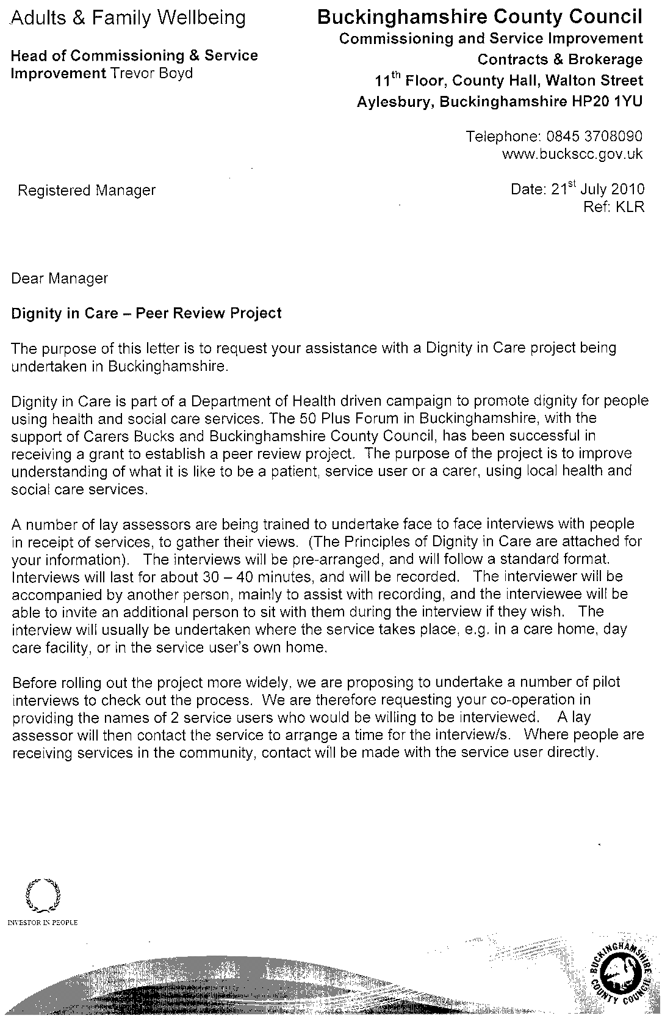

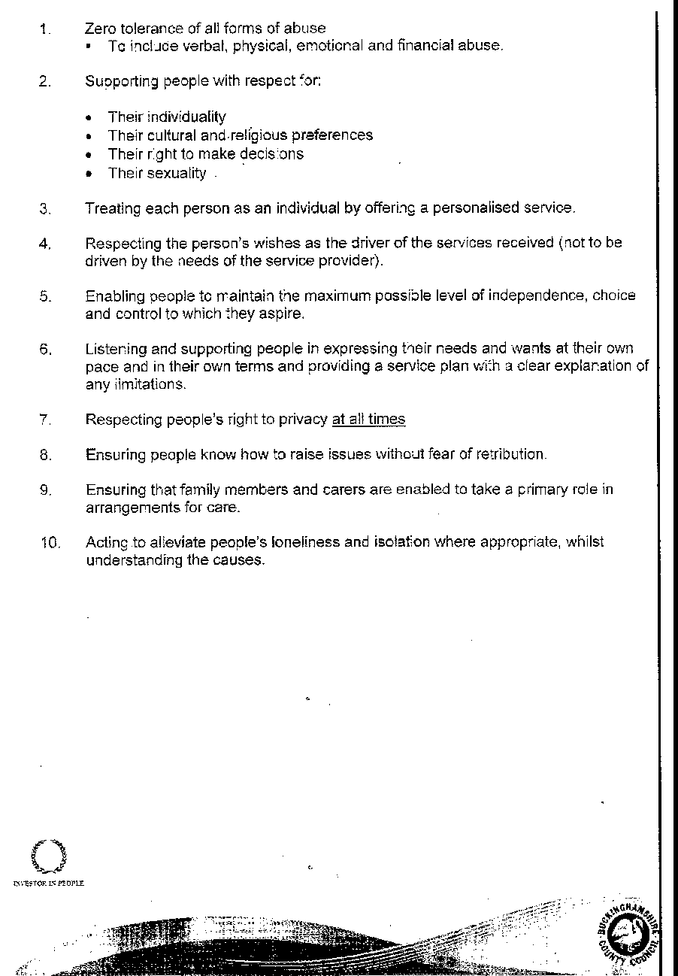

Appendix 3

DIGNITY IN CARE – FEEDBACK FORM FROM INTERVIEWERS

These comments are the interviewer’s perception of what the person interviewed had experienced.
Copies to be sent to the Commissioning and Business Improvement Dept. of Bucks Adult Social Care in the addressed envelope provided
Name of Service……………………………………………………

Question for interviewer | Yes | No | Comments
Has the person interviewed indicated they had experienced any form of abuse?
Did the person interviewed feel they had been treated with respect?

Did the person interviewed feel they had been treated as an individual?
(E.g. did they know if they had a personalised care plan?)
Did the person interviewed feel they had been enabled to maintain the maximum level of independence, choice and control?
Did the person interviewed feel they had been listened to and supported in expressing their needs and wants?
Did the person interviewed feel their right to privacy had been respected?

Did the person interviewed feel able to complain
(E.g. without fear of retribution or other inhibiting factors?)
Did the person interviewed feel the staff providing the services had engaged with family members and carers as partners in care?
Did the person interviewed feel they had been helped by the service to maintain confidence and a positive self-esteem?
Did the person interviewed feel the service acted to alleviate any loneliness and isolation?
Did the person interviewed feel there had been particularly good/bad practices

Any further comments or observations relating to particularly good or bad practice.
Name of Interviewers ………………………………………
………………………………………
Place of interview
(e.g. Care Home; interviewee’s own home etc.)
……………………………………………………………..

Date of interview ………………………………………….

Appendix 4
2ND LETTER TO MANAGERS
Letter to be sent to Managers after they have agreed with the Project Co-ordinator that they will participate.
Dear…..
The ‘Big Idea Project’ for Dignity in Care
‘Thank you for agreeing to participate in this Project which aims to find out from Service Users whether they were/are treated with dignity and respect by the providers of services.
Older volunteers will be trained to carry out interviews and the responses of the users will be tape recorded and the transcripts analysed. Issues arising will be brought to Service Managers’ attention and the outcomes to improve practice will be monitored through the Bucks Older People’s Champions Forum and the Older People’s Partnership Board.
You have been asked to identify a service user who would be willing to be interviewed and I enclose an Information Paper and Consent Form for you to give them. They should complete this and hand it to the volunteers when they come to carry out the interview. (The volunteers will bring a spare, just in case the user mislays theirs).
You will notify the Project Co-ordinator of the contact details.
If the service user is in the community the volunteer will ring them up to make an appointment, if the service user is in residential care the volunteer will ring the Manager or Care worker to make an appointment.
We are focusing interest nationally on this project through the Big Ideas programme for promoting Dignity in Care which has provided £2000 funding.

Yours

Project Manager

APPENDIX 5
INFORMATION SHEET FOR SERVICE USERS
Using Interviews to Improve Services :
What is dignity in care?
Dignity requires the kind of care, in any setting, which supports and promotes, and does not undermine, n person’s self-respect, self-esteem and confidence.
Factors that have been held responsible nationally for the absence of dignity in care include bureaucracy, staff shortages, poor management and lack of leadership, absence of appropriate training and induction and difficulties with recruitment and retention leading to overuse of temporary staff.
In March 2010 Bucks 50 Plus Forum won a national award for” Big Ideas” with a proposal to set up a programme of interviews to be carried out by trained volunteers with people who have recently received care, to find out if they had been treated with dignity and respect.
You are being invited to take part in this piece of work to improve services. Before you decide, it is important for you to understand why this is being done and what it will involve. Please take time to read the following information carefully. Talk to others if you wish.
Ask us if there is anything that is not clear or if you would like more information. Take time to decide whether or not you wish to take part.
What is the purpose of the study?
The purpose of this piece of work is to improve our understanding of what it is like to be a patient, service user or a carer, using local health and social care services. This involves interviewing people who use services or have used services within 28 days of the interview. We hope to use this information to help providers to further improve the quality of their services in respect of the Dignity in Care principles
Why have I been chosen?
We are interviewing a small number of patients, clients, residents, carers who have used or are using services within the last 28 days. You have been chosen at random from these groups of people.
Over the course of this piece of work, we will carry out interviews with two people from each service.
Do I have to take part?
No. It is up to you to decide whether or not to take part. If you do, you will be given this information sheet to keep and be asked to sign a consent form.
You are still free to stop the interview at any time and without giving a reason. A decision to withdraw at any time, or a decision not to take part, will not affect the standard of service you receive.
Will my taking part in this study be kept confidential?
Yes. The interview will be recorded so that the interviewer does not have to take notes. The tape will be typed up so that others can read about your story but we will remove any references that might allow you to be identified. We will ask you to sign your consent to typing up the interview.
There is a possibility that you will say something that might require further investigation. If such a serious, critical incident arises, the interviewer will discuss this with you. You should be aware, however, that they will be obliged to report standards of practice that appear to be unacceptable. This may mean that others become aware of whom you are.
What will happen to me if I take part?
If you agree to take part, you will be interviewed by a trained volunteer. Our interviewers are nearly all local people themselves. They have very few questions because we really want to listen to your story. There will be two volunteers who visit you. The second volunteer is there to operate the recording equipment and to help in any way needed.
We will ask you to describe how you chose your service, what is important to you that you get from a service, what your experience is from the service you receive and if there is anything you would change.
The conversation will last 30-40 minutes. You can stop it at any time for any reason. It will be recorded so that the interviewer does not need to take lots of notes.
Where will the interview take place?
The interviews will be arranged at a time that is convenient for you. We would like to interview people separately from their carers.
What are the possible disadvantages or risks of taking part?
You may find it difficult and upsetting to talk about your experiences. If you feel upset during the interview, remember that you can stop at any time. If you need to talk to someone else after the interview, we will help to arrange that if we can.
What are the possible benefits of being involved?
We want to learn exactly how you feel about your experiences. If you’re happy, it will encourage the Service, NHS and social care to do that more. If you’re not happy, we can learn from you and look to make improvements.
What if there is a problem?
Any complaint about the way you have been dealt with during this piece of work or any possible harm you might suffer will be addressed. You can direct any concerns to the interviewer in the first instance, or you may prefer to contact me (see details below).

Will anything change after the interview?
With your consent, we would like to share the interview (typed up or re-recorded) with those organisations who have been involved. We will only do this where we can also protect your confidentiality.
Your story will be shared with clinical and management teams. They will meet to discuss whether anything should be changed as a result.
Will you tell me what you have changed?
We will write to you soon after the interview to thank you for taking part. We will then write to you again within six months following your interview to tell you what was learnt and what, if anything, will now be done differently. It takes that long because of the process to share the story and then agree any changes that are required.
Who is organising this piece of work?
The study is part of a local piece of work that is being led by the Buckinghamshire 50 Plus Forum. This group has a mix of ordinary people and professionals on it and it exists to press for the highest possible standards of care for those using Health and Social Care Services.
Who will review this piece of work?
Information will be shared with Health and Social Care Services in Buckinghamshire and the Department Of Health.

Thank you for taking the time to read this.

Contact details
For more information, please contact, Joint Commissioning Manager, on 01296 382561.
If you have concerns or wish to complain about this piece of work, please contact, Head of Adult & Family Wellbeing on 01296 383795

Appendix 6

SERVICE USER ‘S CONSENT FORM

Learning from the experience of older people using local health and social care

Name of Interviewer:

Please tick the box for all those statements to which you agree

I confirm that I have read and understand the service user’s information sheet dated April 2007. I have had the opportunity to consider the information, ask questions and have had these answered.

I understand that my participation is voluntary and that I am free to withdraw at any time without giving any reason, without my care or legal rights being affected.

I agree to the interview being recorded on a tape recorder, which I can stop at any time

I consent to my carer being approached to take part in the study

I consent to the interview being made anonymous and typed up and then shared with health and social care staff - extracts may be included at conference presentations and in research publications. Your name will not be used.

I consent to the interview being re-recorded by an actor and shared with health and social care staff

I agree to take part in the above study

Name of Service User
Date
Signature
Name of Interviewer
Date
Signature
Name of Observer
Date

Appendix 7 - LETTER OF AUTHORISATION
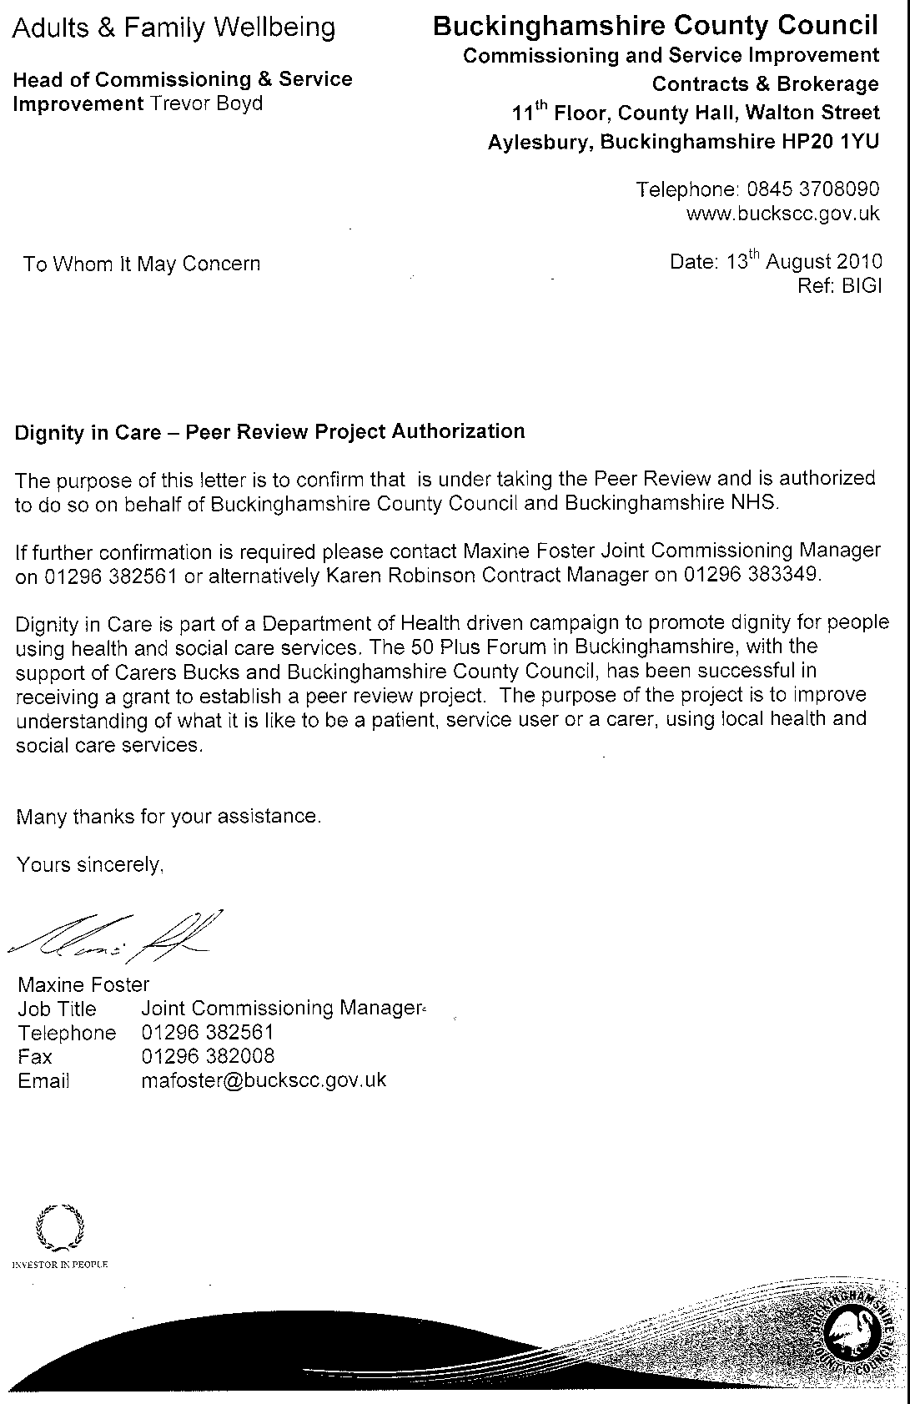

Appendix No 8
ANALYSIS OF INTERVIEWS PRO-FORMA
(for Project Leader and Assistant)

Interviewee Profile:
Sex:
Age: 65+ 85+
Disability:
Ethnicity:
Venue:
Previous services:
Present service: Residential Care Home for how long?
Interviewers:
Others present: helper their status;
Date:
ISSUES | COMMENTS
How was the service
accessed
Privacy

Personal hygiene

Choice (menu)
(carers)
(routine)

Reliability of service

Links with family/friends

Links with Community

Relationship with carers? Other staff

Security for the future

Respect
E.g.: preferred name, Care Plan; knocking on door

Appendix 9

ANALYSIS OF DIGNITY INTERVIEWS

Interviewee Profile:

Total No. | Male | Female | >65 | 65+ | 80+ | Disability |  | Ethnicity
 |  |  |  |  |  | Diabetic | 4
26 | 4 | 22 | 6 | 14 | 6 | Dementia | 3 | British white | 24
 |  |  |  |  |  | Wheelchair | 3 | Afro  Caribbean | 1
 |  |  |  |  |  | Head injury | 3 | Australian | 1
 |  |  |  |  |  | Frail | 3
 |  |  |  |  |  | Walking problems | 3
 |  |  |  |  |  | Learning Disability | 1
 |  |  |  |  |  | Spinal problem | 2
 |  |  |  |  |  | Suicide attempt | 1
 |  |  |  |  |  | Depression | 1
 |  |  |  |  |  | Stroke | 2

Service:

Residential care | 12 | Day Care | 6 | Respite  Care | 4 | Nursing Home | 2 | Home Care | 0 | Meals-on-  wheels | 2

How long service used:

Not known | 20 | Under 1 year | 3 | Over 1 year | 3

Previous services

Not Known | 16 | Day Care | 3 | Other Residential Placement | 3 | Domiciliary | 2 | Sheltered | 1 | Hospital | 1

Others Present

None | 17 | Relative | 4 | Staff | 4 | Student | 2

( note 1 student and 1 staff present at one interview)

Service Accessed by

Interviewee  /friend | 2 | relative | 9 | GP/Health | 7 | Social Care | 4 | Not known | 4

Privacy

Own home | 8 | Satisfactory/pleased | 13 | Not an issue | 3 | Difficulty with night staff | 2

Personal hygiene

Help if requested | 7 | Help with bath/shower | 3 | Satisfactory/  Not an issue | 7 | No suitable aids provided | 2 | Bad experience | 2 | Not discussed | 5

REVIEW OF COMMENTS
(verbatim quotes from interviewees given in italics)

 | POSITIVE | NEGATIVE
Privacy | - Can lock door if wished.  - Staff always knock (many favourable comments)  - Own room highly valued  - Reads all the time in own room  - Chose own room.  - Plays scrabble in her room  - Door shut during interview  - My privacy respected  - staff take residents quietly into their rooms to resolve issues (and shut the door) | - Nervous of complaining  - Would not like a male carer but could voice this  - Some staff come in unexpectedly  (I tell them to go away)  - Chocs disappeared (sad when one little thing aint your own)  - Had to share a room for a while on admission  - Not able to have a key to own room
Personal hygiene | - Can have a bath 1 or 2 times a week. Shower whenever wanted  - Assisted by son and a friend  - Appreciative that staff are there to help if required | - Towels not changed regularly  - Staff sometimes slow to empty catheter bag
Choice (menu)  (carers)  (carers)  (routine) | - Menu varied/very good  - Well-cooked and a variety  - Can choose where to eat (dining/own/quiet room)  - Early morning tea when you want it. Just arrives at the time you’ve said. Wonderful!  - Menu offered weekly for personal choice. Varies and suits diabetics  - One interviewee said choice limited. Another said v. satisfied.  - Varied; nicely served  - Tea making could be improved  - They always oversee it and they always want to see my plate when they take it away.  - Eats alone I have a choice  - Love the food  - Beautifully cooked  - Quite good  - Would like prawn cocktail  - Meals chosen from pictures (learning disabled interviewee)  - Good communication with care workers  - All interviewees praised service  - Keyworker v. important  - staff highly praised but too busy to chat  - Carers approachable  - Able to say if doesn’t want particular carer  - It’s practical ways that they help and guide you to make life easier and better for you – the ever-growing overcoming of small things  - V. good, v.polite and normal people  - I think they are struggling to do a good job for so many people all at once  - Nicely varied. Outings; singsongs  - I like the things I haven’ t been able to do for a long time, like playing chess and having conversations with different people  - Allowed to help wash up/clear tables | - Was able to complain when meat was tough. ‘Marched right off down to the kitchen’  - Asked to move to a quieter table out of the dining room  - Complained occasionally but a  bit nervous to do so.  - Meals not always good.  - Monotonous.  - Not very interesting  - Not enough fresh fruit and vegetables  - new staff need training  Difficult when staff turnover is  high  E.g. for partially sighted they need to say who they are as well as knocking on the door.  - Staff too busy with paperwork  And meetings, meetings, meetings, meetings  God knows what they talk about  - One or two that’s a bit –how can I put it.nasty  - Trouble with night staff – 2 coloured men  - Wait a long time for response to night bell  - Sometimes I can’t understand what they are saying  - No time for a chat,you feel you mustn’t interrupt them really  - No hoist provided in interviewee’s room  - Interviewee could not be changed at night and had to stay in same pad all night  - Only one carer, sleeper-in .6 residents  - They’re very keen on safety
Links with family/friends | 17 of the interviewees had close links with family  5 spoke of close friends  - highly important to those in residential care  - those whose family did not visit – less confident  - some had supportive friends  - most made friends with others using the same service  - contact facilitated by being able to entertain in own room  - Private room available when there are a number of visitors  Most important thing in life is friends, and people and truth
Links with Community  (specifically mentioned) | - visitors  - entertainment  - library/Friend of local library  - outings particularly valued  - hairdresser (much valued)  - keep in touch via magazines/newspapers/  - television  - Visiting pets (e.g. chicks brought to a residential home)  - 2 cars available to take residents out.  - Staff take out shopping  - 2 girls come to play music  - a Church service is held in the home monthly  - Open days much enjoyed  - Enjoys looking out of the window in her room over allotments. And watching the children going to school  - Attends College  - Goes to a coffee morning and a Club  - Attends a choir  - Craft worker comes to the home  - Has the Daily Mail brought in and does the crossword  - Nice to get outside - see life goes on outside | - Would like to go to daycare but not able to be ready for mornings and not allowed to go just for the afternoon  - Only through the Caribbean Centre  - Choir comes in. they bring favorites from past times.  I think they feel we only enjoy things from the past  - Interviewees felt more volunteers could be used in residential care to accompany residents to the shops or a short walk.
Relationship with carers? Other staff/  Residents | - Half those interviewed described it as very good  - Some had concerns re some staff  - One commented on an approachable care manager who visits  - Day care staff described as ‘wonderful’ by most users  - We are well looked after  - Staff very busy but caring  - Care manager comes to check all well  - They don’t interfere. Comfortable, relaxed. We can be rude to one another  - V. supportive GP  - Feels able to ask are Manager for services  - Staff keep saying ‘in a minute’ so calls GP on own mobile phone  - Able to tell senior one and she tells the others  - I’ve been very impressed with the service here  - I think the staff are struggling to do a good job for so many people all at once  - They’ve been lovely people. Like an extended family  - Staff really nice. Volunteers essential to the service.  - They always listen to you. | - Frequent sad comment that staff are too busy to chat  - A member of the night staff suggested the interviewee might try to change his catheter bag himself. He was upset  - Not keen on some other residents  - Not people I would choose to be with
Security for the future | - Residential and nursing home residents unconcerned unless facing a move e.g. from respite to residential care  - Can stay till we die  - A place like this – it’s nice  - After you’ve been away you think ‘thank goodness I’m back’  - I love it here. This is my home now  - If you ring buzzer or call for help they come  - Feels secure- like being at  Home  - Feels safe here- wonderful-like a hotel | - Worried about benefits  - Cost of taxi to college prevents attendance sometimes  - Threatened closure of the Red Cross Day Centre – it is a lifeline. Without it feels she would almost give up and decline  - I will lose a lifeline  - Interviewees in own home: more uncertain re the future  - Feels he hasn’t been listened to  - Own home interviewees more uncertain re future  - Day care users distressed re proposed closures
Respect  E.g.: preferred name  Care Plan; knocking on door | - Respect is going both ways  - They always smile- that’s respect  - They couldn’t treat me any better  - just want to be me  - When I come here I feel we are equal (staff)  - Used to sit around in dressing gown. At first staff used to nag me a bit but the Head, says ‘Well, don’t worry, leave her dignity  - The Centre gave me gave me confidence and helped me to manage myself really. | Worried about further/future cutbacks

Note

Analysis taken from transcribed tapes except 3. Two where the tape failed to work and one where the interviewee had a severe speech impediment).
These were analysed from volunteers’ reports.

Appendix 10

TIME SPENT BY VOLUNTEER INTERVIEWERS
AND VOLUNTEER PROJECT LEADER AND ASSISTANT

Meetings

2010

July 14th Training Day
July 18th & 30th Training re tape recorders
Sept 7th County Hall
October 26th County Hall

2011

January 24th Meeting with Managers
March 9th Review Meeting
May 20th Review Meeting
July 15th Review Meeting
September 30th Review meeting

Visits to 13 establishments/services
NB Meals on Wheels and Caribbean Day Centre 2 separate interviews at each

Therefore 17 visits and 26 interviews
(Approximately 4 hours per interview to include setting up/travel/interview/
tape recording/and filling in feedback forms

TOTAL 104 hours

1 Training Day 7hrs including travel
2 Half day training re tape recorders 6 hrs including travel
7 Review meetings 3 hrs including travel

TOTAL 34 hours per volunteer

Meetings attended by Project Leader and assistant Project Leader

2010
MEETING | HOURS
April 16th County Hall: Standardisation Meeting | 2
May 7th with Regional Representative Dignity in Care | 2
July 18th Training re tape recorders | 3
July 30th “ “ “ “ | 3
Sept.7th Bois Mill | 2
October 26th County Hall- Standardisation Meeting | 2
October 27th Bois Mill | 2
November 11th Meeting with Commissioning and Social Care | 2
December 17th at Chesham | 3
2011
January 19th Visit to establishment plus 2 interviews | 4
January 24th Meeting with managers, volunteers and commissioning | 3
February 25th Bois Mill | 2
March 9th Review meeting with volunteers | 3
March 15th Bois Mill | 2
March 24th County Hall with Commissioning
March 28th Meeting with Social Care and Commissioning | 2
April 5th Older People's Partnership Board | 2
April 27th Bois Mill | 2
May 17th Chesham | 2
May 20th Review Meeting with volunteers | 3
July 6th Meeting with Essex University re the project | 2
July 15th Review meeting with volunteers | 3
July 27th Bois Mill | 2
August 18th Bois Mill | 2
September 26th Bois Mill | 2
September 30th Review meeting with volunteers | 3
October 7th at Beaconsfield | 2
October 26th at Chesham | 2
October 30th Meeting with Commissioning | 2
TOTAL | 66 x 2 = 132

NB
Preparation and follow up 3 hours per meeting (including Minute writing, Agenda generation)
Travel time ½ to 1 ½ hours
Meetings held at Bois Mill; Chesham; Beaconsfield and after meetings at County Hall were between the Project Leader and Assistant Project Leader.

Administrative Tasks

Project Leader and Project Assistant

Liaison and co-ordination of project
Modifying pro formas
Collating statistics
Writing agendas and minutes
Setting up meetings
Dealing with e-mails and telephone calls
Analysing statistics
Compiling and typing Report, summary and figures

Project Leader

Setting up interviews with services
Notifying and supporting volunteers
Debriefing
Reports to Older Peoples Partnership Board, Champions Board
and Bucks 50 Plus Forum
Presenting project at 2 conferences
Attending Dignity in Care subgroup

Costs
Travel
Phone calls
Hand held tape recorders
Room Hire
Tape Transcription

