**DIGNITY ACTION**

**DAY**

**01 February**

**Resource Pack**



**Put Undiginified Care to Bed**

**On Dignity Action Day**

**Donate**

**And Wear Red**

# What is Dignity Action Day?

When the Dignity in Care campaign began in November 2006, the aim was to inspire health & social care staff and local people to place dignity and compassion at the heart of care services, and in their communities. Ten years on and an army of over , 155,000 Dignity Champions are all doing their bit to make a difference in peoples’ lives.

The first Dignity Action Day took place on 25 February 2010 and nobody could have foreseen what a truly memorable day it would turn out to be. The idea really caught the imagination and the hearts of the staff, inspiring many hundreds of them to demonstrate what being treated with dignity means to the more vulnerable members of our society.

Dignity Action Day is set to take place again on **01 February.** It is not necessarily a day for the ‘grand gesture’ but more about taking the time to do something, however small, for people who too often feel isolated and of little value to society. It is also the start of what we hope will be a month of activities, that highlight what people do to promote dignity.

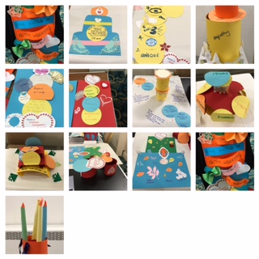

As someone either working on the frontline of health & social care, or closely involved in a voluntary capacity, or who believes in the importance of dignity, you are in a position, through your own actions, to champion dignity as being fundamental to a person’s experience. So please dedicate a day February to supporting Dignity Action day. This year we are also raising funds for the Campaign, by asking Champions to wear red and donate £1 to the Campaign. If only half our Champions get involved in this way, the money raised will enable us to develop further resources and ensure that the message gets on to everyone’s agenda.

This resource pack contains many ideas for those Champions who wish to support Dignity Action Day.

# YOU CAN DO ALMOST ANYTHING!

Dignity Action Day is a day to celebrate all that you and your colleagues have accomplished in delivering dignified care. It is also a day to celebrate with those people at the centre of your care.

Supporting Dignity Action day will:

* Remind society that Dignity is everybody’s business
* Raise awareness of the importance of Dignity in Care
* Promote the services you provide and give someone in you care about an extra special day
* Be part of a national celebration and demonstrate solidarity for Dignity in Care

Dignity in Care materials including posters, leaflets and cards are all available to download free from the website. These will help you raise awareness for Dignity in Care.



# RAISE MONEY TO KEEP THE CAMPAIGN GOING

The Dignity Campaign receives no support from Government or other statutory sources in terms of funding. It relies totally on donations to the National Dignity Council charity. Dignity Action Day therefore provides you with an opportunity to not only promote your commitment but also to raise funds to support the campaign. A Digni-tea event is an ideal fundraiser and any donations no matter how small will keep the campaign going. Any Donations can be paid in via our Just Giving account.

# DIGNITY ACTION DAY SUGGESTIONS

Hold a Digni-Tea event, to raise funds for the campaign and celebrate what you do.. We want you to invite people to have a cuppa and take the opportunity to raise the profile of Dignity, both in the way you work and the importance of the Dignity Dos.

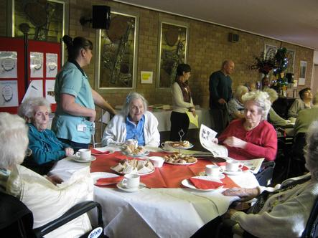

Make sure that you display the [**10 'Dignity Do's'**](http://www.dignityincare.org.uk/_library/Resources/2014/National_Dignity_Council_Card.pdf) and the ASK ME poster.

Organise a learning event for other staff to hear about your dignity initiatives

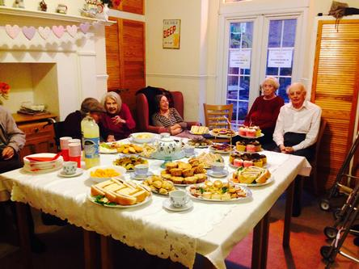

Challenge colleagues to undertake an action to improve Dignity in Care and ask them to feedback about what they did.

Carry out one of our [**Dignity audits**](http://www.dignityincare.org.uk/Resources/Type/resource/?cid=8272)

Hold an open day and showcase the dignified service you provide

Arrange question and answer sessions for staff, the people you care for and carers and invite them to discuss what dignity means to them

Host an internal conference

Supply information and advice about dignity to those who use the service and their loved ones

Ask those you care for to make wishes for the day and do what you can to make them come true

Make a Dignity Cake

Construct a **'Digni – tree'** and invite your clients or guests to write on a leaf what dignity means to them. Another one is red leaves and green leaves, filling in the red leaves for what needs to change - filling in green leaves for ideas on how to change.

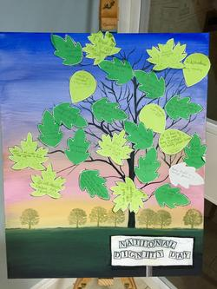

Organise a treat for people receiving care. This could take many forms including pamper sessions, local trips, special guest visits or taster sessions such as computing, tai chi, bowls, music, dance, quiz nights, bingo

Organise an intergenerational visit to a school or community group

Create a [Life Story box](http://www.lifestorynetwork.org.uk/) for residents

Help those you care for with their hobbies and interests

Hold a party to celebrate Dignity Action Day and get everyone involved

Put up a dignity display in your place of work. You can download resources free from the website.

* + - Capture and draw attention to the initiatives you have implemented in your place of work to support dignified care
    - Make a poster publicising what else you are doing to support Dignity Action Day

Utilise your website and newsletters to promote dignity - Use the ASK Me poster to do this.

Tell your friends, family and colleagues about Dignity Action Day. If you use online social networking tools such as MySpace, Facebook, Twitter, Bebo, or have your own online blog or organisational website or email network, use these to help spread the word

Issue press releases about what your organisation is doing to support dignity action day

Introduce the Dignity in Care campaign to your workplace by using [downloadable resources and materials](http://www.dignityincare.org.uk/Resources/)

Get a colleague to [sign up as a Dignity](http://www.dignityincare.org.uk/) [Champion](http://www.dhcarenetworks.org.uk/dignityincare/BecomingADignityChampion/)

Don’t forget to wear your Dignity in Care badge or wristband. If you are signed up to the national campaign via our website and don’t have a badge or wristband you can purchase one from us through our [website](http://www.dignityincare.org.uk/).

If you are able use the day to raise funds to help the campaign continue. Donate via our Just Giving Page.

**WHERE ONE PERSON LEADS ANOTHER WILL FOLLOW:**

Register your Dignity Action Day activities on the Dignity in Care website and include details of any help you may require on the day. Importantly we need to share these to inspire and encourage others. Be proud of your involvement with Dignity Action Day.

Take a look at our Dignity Action Day activities pages on the website to get an idea of what others are doing on the day.

**Dignity Action Day is supported by the National Dignity Council and the Dignity in Care campaign. Visit us at www.dignityincare.org.uk**

If you wish to support the campaign further, please sign up as a Dignity Champion and take a look at our toolkit for action detailing what health and social care staff and members of the public can do on an ongoing basis to support dignity for people in care.

# HOW TO HELP THE PEOPLE YOU CARE FOR GET THE MOST FROM THE DAY:

* Include everybody in discussions about what to do on the day
* Invite people to participate – it does not have to be about you providing the activity necessarily. The people you provide care for could spend time sharing a skill with others
* Suggest a choice of activities for people to choose from
* Ask people to invite their family and friends along
* Encourage people to discuss what dignity means to them
* Create a wish tree with leaves in red for wishes and green for achievements
* Use the Dignity Postcards to seeks feedback on your service.

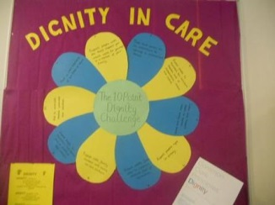

# HOW TO HELP YOUR ORGANISATION GET THE MOST FROM THE DAY:

## Making Sure Everyone Knows What You are Doing

It is important not to assume that everyone knows what you are planning. Get as much support as you can for Dignity Action Day by ensuring everyone involved in the organisation knows what is going on. Invite everyone along. You can use the sample newsletter article and flyer attached to this pack to publicise your activity.

You could contact local media who may be interested in covering your activity. Many journalists love person centred stories so you can tell them how you are improving the care of individuals. We have a sample press release at the end of this pack that you may wish to use to send to local media/press.

## Don’t let it end there

It’s important to keep the momentum of Dignity Action Day going throughout the year. You could use the day to make plans for further improvements/changes in the year to come. Remember to keep telling people about the work you are doing.

# CHECKLIST FOR SETTING UP EVENTS FOR DIGNITY ACTION DAY

If you do decide to set up an event or activity here are a few simple guidelines to help you on your way:

1. Start preparations as early as possible
2. If you cannot complete your idea on Dignity Action Day choose a date as close to Dignity Action Day as possible
3. Enlist a committed team of people to support you
4. Involve everyone in planning the event e.g. patients, residents, management, carers
5. Decide what you want to achieve and your aims for the day
6. Identify potential partners and volunteers to help you. Do not forget when you fill in the form online to update us about what you are planning, there is the opportunity to detail what extra help you need. Other champions and members of the public will see this and can volunteer their time to you
7. Decide if it would be appropriate to invite along any local celebrities. This will help you raise the profile of dignity and your organisation. It may also help you obtain press coverage
8. Consider financial implications (remember there are lots of activities you can do that do not cost you anything – be innovative)
9. Organise a plan of action and distribute tasks
10. Let us know what you are doing by completing the online activites form, and get yourself on the map.
11. Send out invitations as soon as possible
12. Plan your publicity
13. Arrange for someone to take pictures on the day so that they can be uploaded onto the Dignity in Care memory book afterwards

After the event is completed do not forget to evaluate what you have done to make it easier in the future if you are planning a similar event.

1. Thank everyone involved
2. Ask for feedback on the event from everyone and use this to build on for future events
3. Evaluate what you have achieved- is there something you would like to repeat on a regular basis?

# SAMPLE PRESS RELEASE

[Organisation Name] Supports Dignity Action Day

Most of us at some point in our lives will be in contact with care services, be that in our work, as a service user, carer, relative or friend and when we do we hope we will be treated with Dignity and respect. Over 2 million health and social care staff in the UK work around the clock to provide support and care for those in need. Over 155,000 Champions from all walks of life have joined forces to provide a more dignified service for everyone

[Organisation Name] is helping to make sure that dignity is a reality for all. Over and above the care that [Organisations name] provided on a daily basis we are running an event as part of a national day of action to promote Dignity in Care.

[Organisation Name] will be [enter activity] this will involve [enter who] will be held on [enter details] at [enter venue]. The activity will promote the dignity of those in the care of [Organisations name] by [enter how].

[Enter personal account of an individual in your care that will benefit from your chosen activity: this is likely to be the perspective journalists will focus on]

A spokesman for [Organisation Name] said: [provide a quote which may include: why they the organisation is choosing to support Dignity Action Day, and what you hope to achieve]

Dignity Action Day is a national initiative led by the Dignity in Care Campaign and its key partners to bring staff and members of the public together to make a difference to those in care.

In the words of Joan Bakewell who supports the campaign *“Dignity Action Day highlights a more respectful way of behaving towards vulnerable people. The very old and the very young clearly need our respect, but it wouldn't do any harm to spread the dignity message across the population then we can all benefit."*

Dignity Action day gives everyone the opportunity to contribute to upholding people’s rights to dignity and provide a truly memorable day for people receiving care. Dignity Action Day aims to ensure people in care are treated as individuals, are given choice, control and a sense of purpose in their daily activities and are provided with stimulating activities.

Anybody can support dignity action day to find out more log onto [www.dignityincare.org.uk](http://www.dignityincare.org.uk/) where resource packs full of ideas and useful information for staff and members of the public to support Dignity Action Day can be found.

## Notes to Editors:

[Add Organisation details & history] [Organisation contacts for further information]

## The Dignity in Care Campaign

The Dignity in care Campaign, which launched in November 2006, aims to stimulate a national debate around dignity in care and create a care system where there is zero tolerance of abuse and disrespect of adults. It is led by Government in partnership with many organisations that provide and commission care and protect the interests of those using care services and their carers.

**The Dignity Dos.**

High quality care services that respect people’s dignity:

* + Have a zero tolerance of all forms of abuse
  + Support people with the same respect you would want for yourself or a member of your family
  + Treat each person as an individual by offering a personalised service
  + Enable people to maintain the maximum possible level of independence, choice and control
  + Listen and support people to express their needs and wants
  + Respect people’s right to privacy
  + Ensure people feel able to complain without fear of retribution
  + Engage with family members and carers as care partners
  + Assist people to maintain confidence and a positive self esteem
  + Act to alleviate people’s loneliness and isolation

For further information on the Dignity in Care Campaign, or to sign up to become a Dignity Champion see [www.dignityincare.org.uk](http://www.dignityincare.org.uk/)

# SAMPLE EXTERNAL NEWSLETTER TEMPLATE

[Organisation Name] is participating in Dignity Action Day – a day that brings staff and members of the public together to make a difference to those receiving care.

We will be [enter activity] this will involve [enter who] will be held on [enter details] at [enter venue]. The activity will promote the dignity of those in the care by [enter how].

[Enter personal account of an individual in your care that will benefit from your chosen activity]

Dignity Action Day gives everyone the opportunity to contribute to upholding people’s rights to dignity and provide a truly memorable day for people receiving care. So if you want to get involved contact [add details] or if you want to find out more about Dignity Action Day and get involved with other activities that are happening around the country go to [www.dignityincare.org.uk](http://www.dignityincare.org.uk/)

# SAMPLE DIGNITY ACTION DAY FLYER

WE ARE SUPPORTING

**DIGNITY ACTION DAY**

**WE CAN MAKE A DIFFERENCE**

# PLEASE JOIN US TO PROVIDE A TRULY MEMORABLE DAY FOR THOSE WE CARE FOR

**TITLE [ENTER TITLE OF EVENT] DATE [01st FEBRUARY]**

**TIME [ENTER] VENUE [ENTER]**

**CONTACT DETAILS [ENTER DETAILS TO FIND OUT HOW OTHERS CAN GET INVOLVED IN YOUR ACTIVITY]**

**[ENTER TEXT ON WHAT WILL HAPPEN ON THE DAY, WHO IS INVITED, WHAT OTHERS CAN DO TO HELP]**