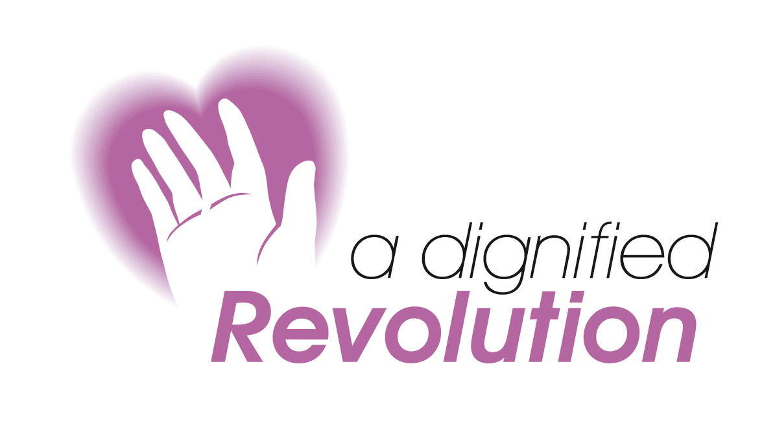

Dignity is More Than Just a Word
Mae Urddas yn Fwy na Dim Ond Gair

Perceptive Professionals Embedding Dignity and Respect in a Care Environment

Wednesday 3 February 2010
Cardiff

A Dignified Revolution is a group of individuals, the majority of whom are nurses, who want to improve the care of older people in hospital. It was launched in January 2008. The impetus to establish the initiative was driven by the distress that these individuals had experienced because of the poor care that their relatives had received whilst in hospital, and their concern that others might find themselves in the same situation.

This workshop is focused on fine tuning communication and listening skills to enrich your relationships with patients/clients, relatives and carers (and your colleagues).

Workshop Objectives

- Appreciate more fully what dignity means to a patient
- Experience what being treated disrespectfully feels like
- Practice using practical tools to increase the respect shown to patients
- Understand that staff are also entitled to be treated with respect
- Enhance your communication skills
- Take an action plan back to the workplace

PROGRAMME
9.00 | Registration & coffee
9.30 | Caring without dignity
10.30 | What dignity means to you/how do you know that you respect others?
11.30 | Seeing the world from other perspectives: the role tree
12.30 | Lunch
1.15 | Tools and techniques for maintaining dignity
- Dignity challenges
- Reflective listening
- “When you were…”
- Diagnosing behaviour
- When feedback challenges principles
3.15 | Deep impact: embedding respect in your organisation
4.00 | Action planning/review
4.30 | Close

The knowledge gained from this event will meet the requirements of the
NHS Knowledge & Skills Framework (NHS KSF)

Dignity is More Than Just a Word
Mae Urddas yn Fwy na Dim Ond Gair

Wednesday 3 February 2010
Cardiff

BOOKING FORM (please copy if more than one booking)

Name:
Job Title:
Department:
Organisation:
Address:
Tel:
Fax:
Email:
Special Requirements:

Fees
Fees are £135.00. An invoice will be raised on receipt of this booking form.
Please make cheques payable to A Dignified Revolution

Cancellation Policy
Bookings can be cancelled for a full refund if received in writing or by email 14 days before the event. There are no refunds after that date and outstanding invoices must be settled even if the place is not taken. Substitutes are permitted at any time

Access:  We will do our best to ensure that everyone wishing to attend our events is able to fully participate. Prospective delegates with specific requirements should contact us at the earliest opportunity so that we can consider how we can best assist you. | Please post or fax this form to:  Monica Dennis  A Dignified Revolution  Britannia House  11 High Street  Cowbridge CF71 7AD  Tel: 07811 159800  Fax: 01446 774864  Email: info@dignifiedrevolution.org.uk  www.dignifiedrevolution.org.uk

“Excellent day – very thought provoking”

“Thoroughly recommend this training to all involved in communicating with others, but particularly in the caring/social sector”

This workshop can also be delivered as an in house event
For further details contact:
Monica Dennis -07811 159800

