Dignity Champions go interactive
One of the key themes coming out of the Patient Staff Conversation Events held in October was that Dignity Champions wanted more opportunities to collaborate and share learning around Delivering Same-Sex Accommodation (DSSA). In response to this, the DSSA programme team has established a series of webinars on DSSA ‘hot topics’.
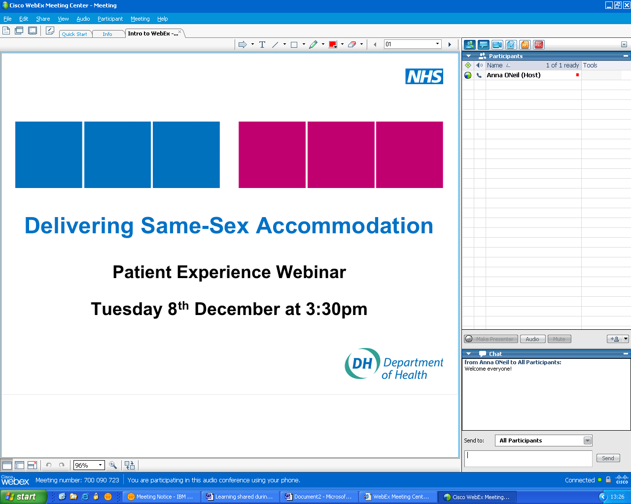
Figure 1: Screenshot from the Patient Experience Webinar
Webinars are a new and interactive way of collaborating, enabling Dignity Champions to share learning in an interactive forum without having to travel to meet one another. It’s greener too! All you need to participate is access to the internet and a phone. At the beginning of the session we provide a short tutorial, so that everyone knows how to use the software.
The first webinar (on “Patient Experience”) took place on Wednesday 8th December. The session covered:
- an overview of the work going on at national level around measuring patient experience, prepared by the South East Coast SHA DSSA Lead (Branita Mills)
- a presentation by Alison Flaherty, a User Involvement Worker from Northumberland, Tyne and Wear NHS Trust, on her perspective of user involvement and how it has influenced delivery of same-sex accommodation in her organisation
- an opportunity for participants to share some of their own experiences/perspectives of patient involvement and how they have used it to shape their services.
The session was really well received:
‘I found it very useful...I most liked the interaction and sharing stories between people who wouldn't normally meet...I was impressed with the enthusiasm and drive that is out there’ (DSSA Patient Experience Webinar participant)

We are keen to run more DSSA hot topics webinars and have had feedback that there is particular interest in attending sessions on governance and leadership, definitions of same-sex accommodation, commissioning and contracts, mental health, building and facilities, day care and endoscopy. However, to do this we need your help! If you are interested in getting involved and sharing your experiences of these or any other DSSA topics, please email dssa@dh.gsi.gov.uk or phone Anna O’Neill on 07894 491 619.
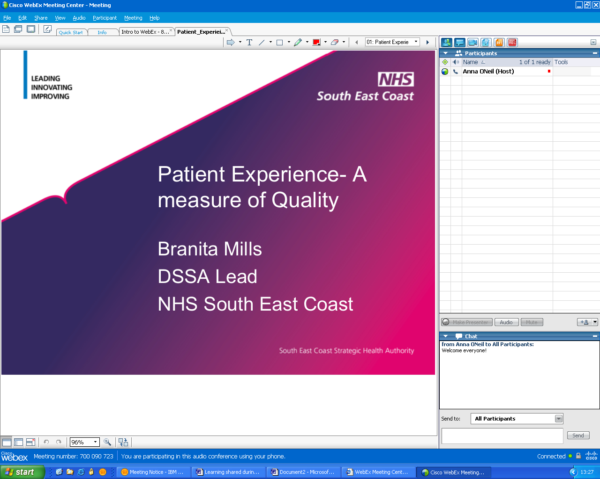
Figure 2: Screenshot from the Patient Experience Webinar
‘I really enjoyed the experience and would recommend volunteering to share your experience as part of a DSSA WebEx to others.’ (Alison Flaherty – presenter)
If you would like to know more about delivering same-sex accommodation see the DSSA website, which includes top tips, tools and case studies: www.dh.gov.uk/en/Healthcare/Samesexaccommodation/index.htm

