Welcome to our monthly newsletter

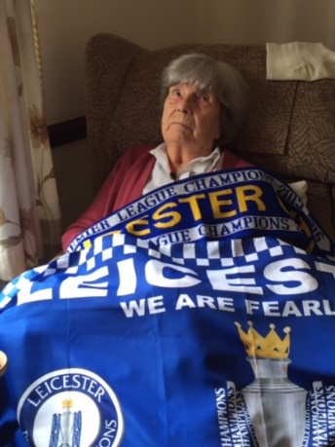
Hello everyone

Welcome to the August edition of the Red Homes Community Newsletter. This is designed to keep you up to date with what is happening within the Red Homes Community.

We may not have won the Euros, but Leicester did get to the top of the Premier League, much to Mrs Ward’s delight!

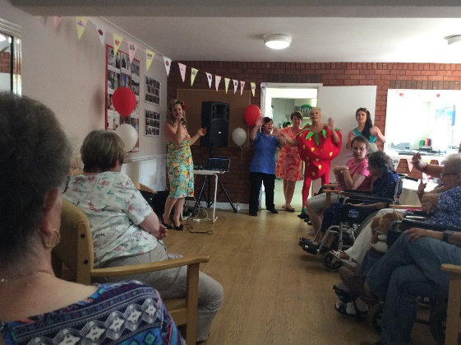

Red Roofs Strawberries & cream tea!

BOAT TRIP
Residents have been enjoying this year’s boat trip. The rain held off and everyone enjoyed the afternoon sailing down the River Trent.
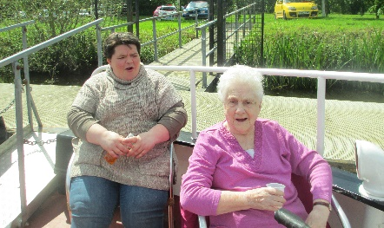
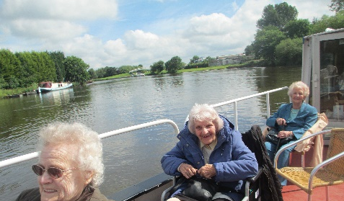
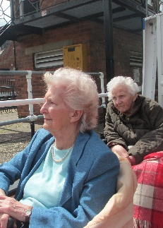

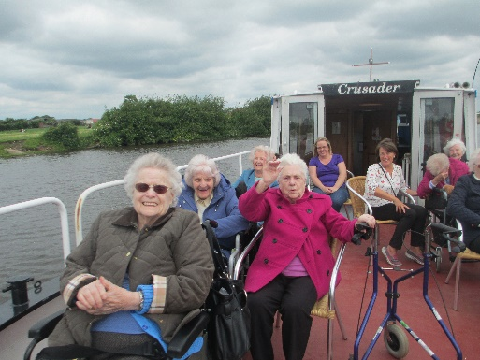
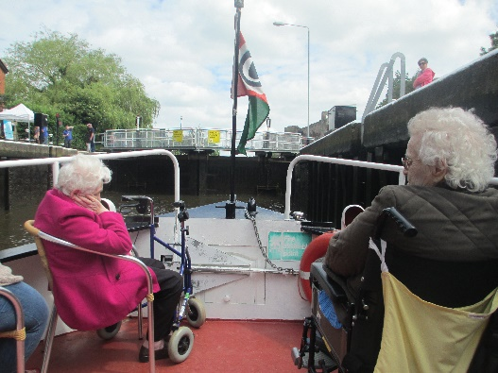

NEWARKS ANSWER TO MARY BERRY
Residents at Red Rose Nursing Home have been enjoying afternoons baking with cook, Jane.

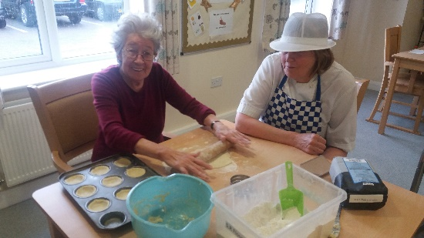

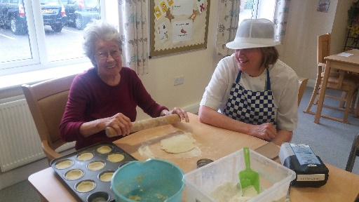

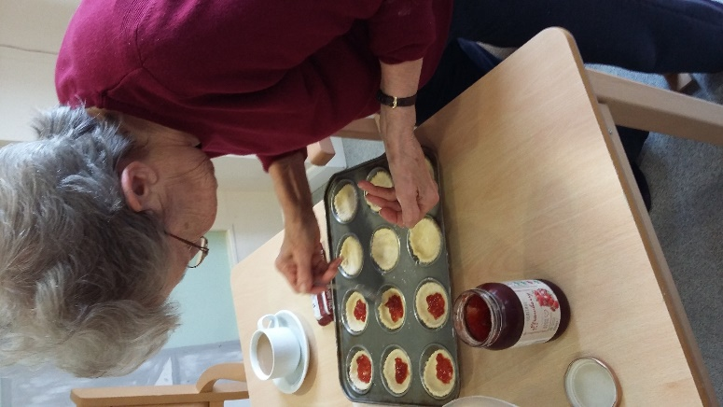
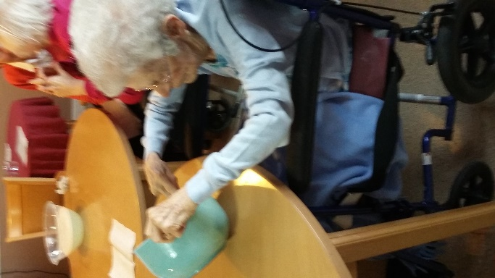

SUMMER IS HERE
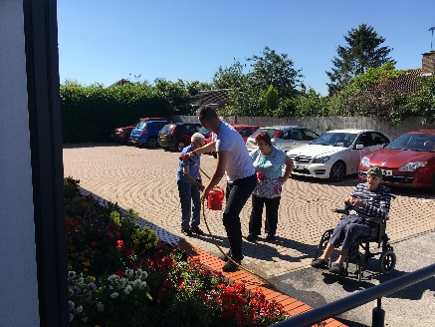
Residents have been enjoying he sunshine with a spot of gardening this month. At Red Rose some of the residents have been watering the plants.

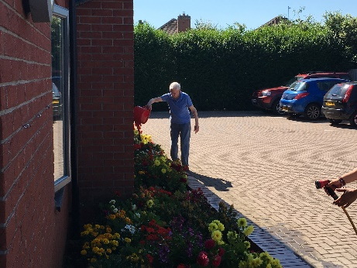

CREAM TEA AFTERNOON
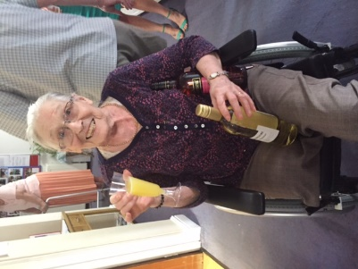
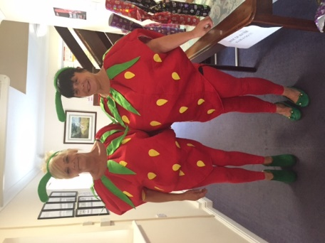
At Red Roofs the residents enjoyed a strawberries & cream tea afternoon, and even some of the staff dressed up as strawberries!! They managed to raise and amazing £218.60 for the residents fund.

CARE CERTIFICATE
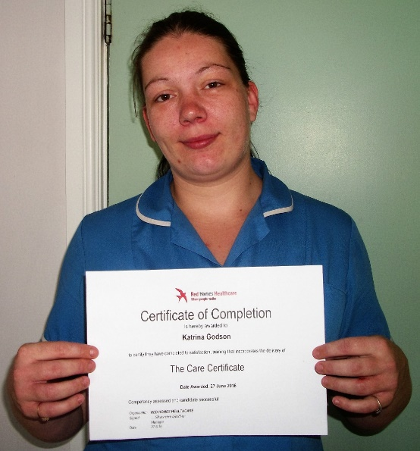
A number of our staff are now starting to complete their Care Certificate, Katrina (pictured) is the first to finish the award.

Others to complete the award are:

Danielle Boddy
Sandra Boddy
Glenys Crane
Sue Cristian
Jane Smith
Gillian Spendlow
Sharon Gatus
Cara Salmon
Pricilla Clark
Nancy Ibanez
Margaret Mills

STAR AWARDS
Our staff are important to us and we wish to recognise the hard work they put into delivering the high standards of care. I am sure you want to nominate staff too, you will find nomination slips and a box in the main reception to the home we will be opening the box at the end of the month. The person with the best nomination will win £100

This month’s winners are:

Amy Martin – Red Oaks

Jackie Proctor – Red Roofs

Denise Davies – Red Rose

PUZZLE PAGE

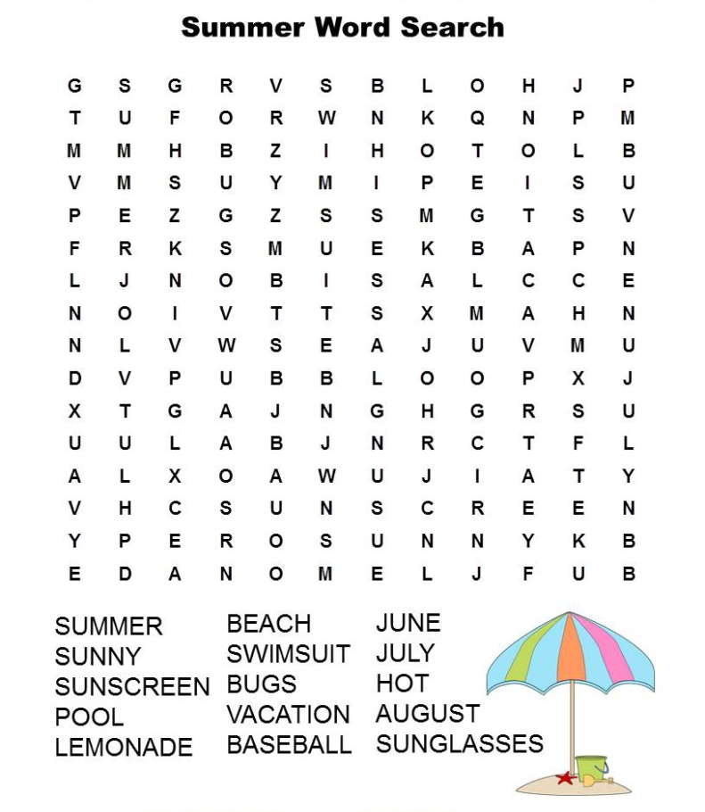

UPCOMING EVENTS

8th August – Boat trip
8th August – Bill & Hillary at Red Rose
14th August – Songs of Praise at Red Roofs
15th August – Alex Belfield at Red Rose
16th August – Holy Communion at Red Roofs
18th August – Motivation & Co at Red Roofs
22nd August – Bill & Hillary at Red Roofs
23rd August – Boat trip
30th August – Move it Mobility at Red Roofs

Red Homes Community Contact details
Red Rose  32 Brockton Avenue  Farndon  NG24 4TH  Tel: 01636 673 017  Fax: 01636 707 734 | Red Firs  Strawberry Hall Lane  Newark  NG24 2EP  Tel: 01636 700 770  Fax: 01636 610 319
Red Roofs  35a Grange Road  Newark  NG24 4LH  Tel: 01636 707 298  Fax: 01636 707 298 | Red Oaks Care Community  116 Clipstone Road West  Forest Town  NG19 0HL  Tel: 01623 644 195  Fax: 01623 429 977
enquiries@redhomes.com

