**NATIONAL DIGNITY COUNCIL ANNUAL REPORT**

# 2023-2024

***Dignity in our Hearts Minds and Actions***

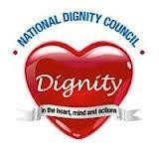

**ANNUAL REPORT 2023-2024**

## OPENING COMMENTS

**CHIEF EXECUTIVE’S COMMENTS**

Jan Burns MBE

Chief Executive Officer

In summary our achievements this year have been:-

* Increase in the number of **champions** to over 172000.
* Continued to maintain the website in an up-to-date and user-friendly state.
* Continued to increase the number of members on the Dignity in Action Facebook page. Now over **3.900** members.
* Continued to maintain positive links with key stakeholders.
* Used the Dignity in Action FaceBook Page and Website Discussion Forum to share practical tips, support each other and raise key topics for a wider debate.
* Established an Instagram presence.
* Held another successful Dignity Action Day – despite the financial situation, and the concerns regarding COVID variants, and staffing shortages, many services again found ways of celebrating and showcasing their positive approaches to Dignity.
* Raised funds through Dancing with Dignity events.
* Promoted and disseminated the Dignity Postcards – since we started over,000 of these have been sent out to organisations, and we are grateful for the support received from Spectrum Consortium towards the funding of these.
* Meeting administration has been excellent
* Continued to ensure that the costs of supplying wristbands and badges are covered, and increased the range of organisations using these resources.
* Maintained links with Champions and other stakeholders.
* Maintained and developed the production of a regular Newsletter and received very positive feedback for its content.
* Continued to promote our suite of audit documents.
* Maintained strong links with, key stakeholders - Care England, National Care Association, NICE and SfC.
* Represented the Council as speakers on National Events including;

Access Group, Medway Council, Kings Fund [Chaired Panel on Dementia Summit0]

* Represented the Council on CQC Provider and LA/ICS Advisory Board meetings
* Been part of judging panels at Staffordshire Dignity Awards, Great British Care Awards
* Supported the development of active champion networks.
* Raised funds/donations by working with a number of health and social care services to promote dignity, and person centred practice.
* Continued to promote our baseline and supervisory training packages to promote a dignified culture in the workplace.
* Managed to secure funding from CQC to work with them during 2024-2025 on the Share for Better Care campaign.
* Maintained solvency, despite needing to rely on donations and receiving no grant funding.

So despite the challenges the Trustees and the campaign have identified a number of opportunities for the forthcoming year:

* Dignity Action Day continues to provide a real opportunity for the promotion of Dignity whilst raising the profile of the Council and the Campaign.
* Dancing with Dignity continues to provide the opportunity to celebrate, raise funds and have fun.
* To ensure that the resources on our website are current, wide ranging, and useful to both champions and the public. – We are working with our website provider to make searching for resources, [both our own and others] easier, thereby ensuring wider access.
* Applying for funding for specific projects to enable the Campaign to grow and be targeted, at areas in most need.
* Working closely with others to develop our contact with citizens and thus meeting our charitable objects.
* Working on developing and sustaining links with Health Colleagues.
* Continue to develop our suite of audit documents.
* Promote the Dignity Do’s for both young people and adults.
* Develop local Dignity Champions who are able to speak to staff teams and local groups.
* Develop our use of Podcasts VODPOD – Voices of Dignity Podcast as a tool to encourage debate and showcase positive dignified outcomes.

### SOME EXTRACTS FROM DANCING FOR DIGNITY EVENTS 2023

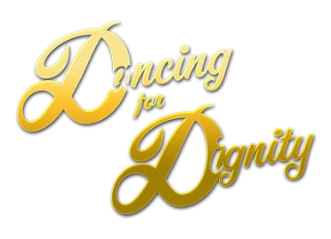The pictures that have appeared in this report are taken from the Website and FaceBook



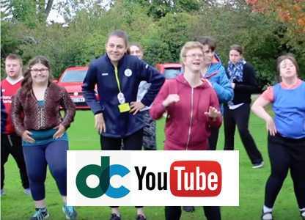

**Derwen Dances for Dignity**

Here's a vibrant, fun clip produced by Derwen College that epitomises Dancing for Dignity.

* [**Watch the video on Youtube (opens new window)**](https://youtu.be/SQfEw2TKuNM)
* You can also watch our Chief Executive Jan Burns MBE doing her Dance for Dignity at
* <https://www.facebook.com/share/v/HYvwRKCMX8D3yPy9/?mibextid=K35XfP>
* 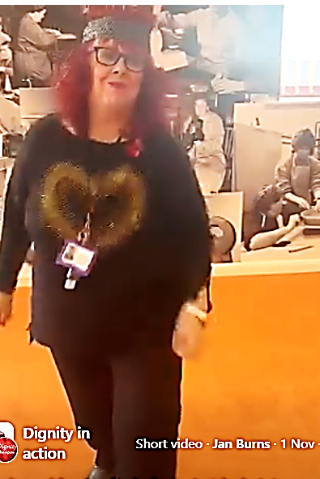

### SOME EXTRACTS FROM DIGNITY ACTION DAY 2023 MEMORY BOOK

The pictures that have appeared in this report are taken from the Memory Book and the entries were chosen at random.



**ACORN LODGE HAD A FUNDRAISING EVENT FOR DIGNITY**

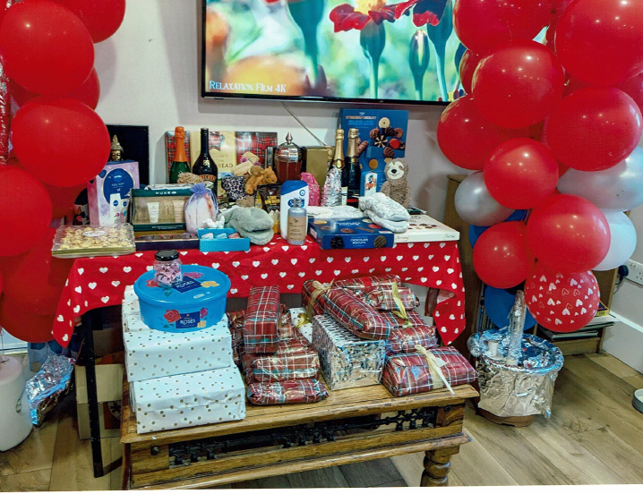 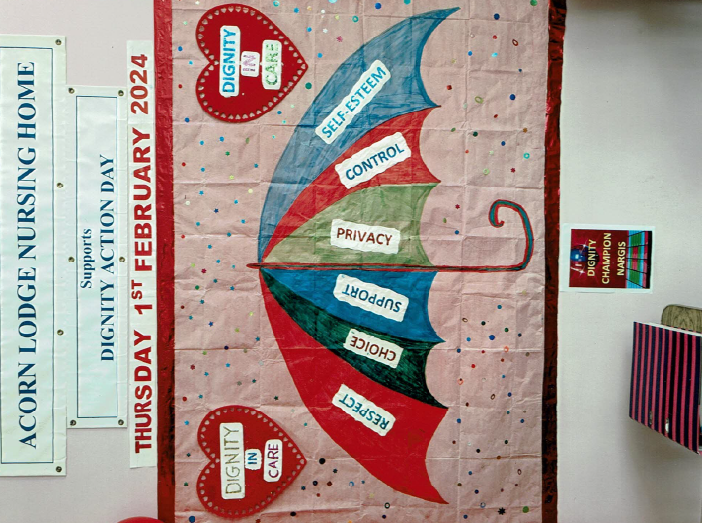

We held a Digni-Tea & Cake Afternoon, where staff & clients wore red and took part in making a Digni-Tree. We wrote on leaves what dignity meant to us. We danced, laughed and made happy memories. X

BRACKENLY AND BRIARDENE

On Valentines day this year our creative homes Activity Champions and staff organised a joint Dignity Valentines afternoon. Our Pyjama party themed event involved music, bingo and afternoon tea .

Our theme was "individuality and dignity" and all our residents enjoyed taking part in a wonderful affirming art activity to showcase their individual hand art works and just how amazing we are when we work together.

Our residents thought it was amusing to see staff in their pyjamas (it's usually the other way around!) and had a fun, thought provoking and highly enjoyable afternoon.

THE GLEN’S DIGNITY TEA PARTY

We enjoyed a cup of tea and delicious cakes while chatting about what dignity means to us. Each resident helped to write a leaf for our digni-tree with feedback about the care they receive and positive changes which we can make so we are more dignity conscious.

**ACCOUNTS 2023-2024**

**National Dignity Council**

**Treasurer’s Report to the AGM**

**Statement of Accounts and Balance Sheet**

**for the year ended 31st March 2024**

|  |  |  |  |
| --- | --- | --- | --- |
| **National Dignity Council Accounts - 31st March 2024** | | | |
|  |  | **2023-24** | **2022-2023** |
| **INCOME** | |  |  |
| Corp income/training | | £2,072.00 | £2,462.45 |
| Amazon | | £21.44 | £13.03 |
| Donations | | £425.00 | £485.00 |
| DONR | | £37.31 | £96.90 |
| Sales | | £4,506.03 | £3,289.16 |
| Conference | | £388.98 | £665.29 |
| DAD -Dancing | | £397.27 | £1,071.00 |
| Training [packs] | | £400 | £1,200 |
| Just Giving | | £1,229.63 | £222.16 |
| PayPal | | £480.69 | £478.76 |
|  | |  |  |
|  | | **£9,958.35** | **£9,983.75** |
| **EXPENDITURE** | |  |  |
| Insurance | | £313.19 | £307.04 |
| Website costs | | £4,958.56 | £5230.66 |
| Badges/Wristbands/Dos/Admin/travel/ stationery/postcards | | £3,052.00 | £582.00 |
| Post | | £1,723.82 | £1,704.90 |
| Honorarium | | £1,000 | £750.00 |
| Just Giving | | £216.00 | £216.00 |
|  | |  |  |
|  | | **£11.263.57** | **£8,790.60** |
|  | |  |  |
| **Surplus /Deficit** | | **-£1,305.22** | **£1,193.15** |
| **BALANCE SHEET** | |  |  |
| Opening Balance | | **01/04/23**  **£9,550.59** | **01/04/22**  **£8,357.44** |
|  | |  |  |
| Surplus /Deficit | | **-£1,305.22** | **£1,193.15** |
|  | | **£8,245.37** | **£9,550.59** |
| **Represented by** | |  |  |
| Cash At Bank | | **£8,245.37** | **£9,550.59** |
| Creditor | | **£0.00** | **£0.00** |
| **Closing balance** | | **31/03/2024**  **£8,245.37** | **31/03/23**  **£9550.59** |

. **Notes to the accounts**

**i)**Sales – slightly up o previous years and there is around 50% of the purchases of badges and postcards in stock.

**ii)**Where it has been difficult to identify all training pack /jar of hearts initiative sales they are accounted for within the sales figure

**iii)** Just giving has become a more popular platform justifying the cost of our presence on this means of giving

**iv)**Amazon Smile scheme is no longer in operation

**v)**The deficit of £1,305.22 of this last year is covered by the stock in hand at an approximate cost of £1500

Jane Finnerty

Honorary Treasurer 07.05.2024

### CHARITABLE AIMS AND OUR KEY WORKPLAN AIMS

Charitable Objects

* The preservation and protection of health for the public benefit by promoting best practice in standards of care, in particular the importance of dignity in care

* For the purpose of this clause ‘dignity in care’ means care, in any setting, including but not limited to hospitals, residential homes and care homes which support and promotes, but does not undermine, a person’s self respect.

Key Workplan Aims

* Increase suite of audit tools
* Improve the accessibility of the website and availability of resources for Champions
* Maintain a regular newsletter
* Improve and build on links with Dignity and other networks. Including the use of the Facebook page and Discussion Forum.
* Maintain and forge robust strategic links with key stakeholders.
* Ensure the sustainability and financial probity of the Council.
* Promote National Dignity Day as a vehicle for raising the profile of the Campaign.
* Use our web events to focus on Making the Invisible Visible and ensuring a voice of all.
* Ensure that we bid for and deliver projects that enhance the abilities of citizens to have a voice in ensuring that Dignity remains high on the agenda.

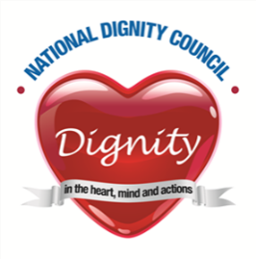

### TRUSTEES AND COUNCIL MEMBERS FOR 2023-2024

TRUSTEES

Jan Burns MBE Chief Executive Office appointed

September 2022

Lesley Flatley Chair retires September 2024

Trustee Retires September 2024

Alan Clarke MBE Trustee retires September 2025

Roisin Burton Chair retires September 2024

Trustee retires September 2025

Alex Lewney Trustee retires September 2026

Amanda Cain Trustee appointed October 2023

Retires September2026

COUNCIL MEMBERS

|  |  |  |  |  |
| --- | --- | --- | --- | --- |
|  |  |  |  |  |
| Jane Finnerty. |  | Treasurer | |  |
| Liz Taylor |  | Secretary /Administrator | |  |

Rekha Elaswarapu Ambassador retires September 2024