NATIONAL DIGNITY COUNCIL ANNUAL REPORT

2022-2023
Dignity in our Hearts Minds and Actions
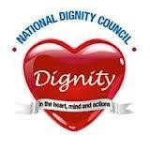

ANNUAL REPORT 2022-2023

OPENING COMMENTS
This last year has seen a restructuring of the Council’s governing body, with the appointment of a Chief Executive Officer, and a search for new Trustees to fill gaps in the representation on Council. Jan Burns MBE took on the role of Chief Executive and this has mean that the Council has been able to retain her skills and contacts whilst freeing her up from Chair’s duties. This has enabled a better focus on the development of strategic contacts and links as well as enabling Jan to speak at a range of conferences and events. Lesley Flatley took on the Chair’s role and despite the pressures of her working life has provided excellent leadership to the Board of Trustees. At the end of the year we welcomed Alex Lewney to the Board and he has brought new ideas and new contacts, which bodes well for the future. Our links with the Care Quality Commission have been developed and we look forward to working in collaboration with them in the future. We are also grateful to the both Nadra Ahmed CBE and Ian Turner of the National Care Association [merged with the Registered Nursing Homes Association] for their continued practical support to the Council in providing an office base.
CHIEF EXECUTIVE’S COMMENTS
I would like to say a few thank yous. To everyone who has supported the Dignity Campaign in the last year, a tremendous thank you, without you we would not be able to achieve all we have. To the Trustees who have given unstintingly of their time and energy a big thank you, and to those organisations who gave us support. A special thankyou too to our Treasurer Jane Finnerty for looking after our finances so well and to our faithful Secretary, Liz, who goes way beyond an administrative role, she is no doubt a major asset to the functioning of our charity. And, of course last but not least to all of our Dignity Champions who continue to make a difference on a day-to-day basis to a range of people in a variety of settings. Thank you to each and every one of you for sharing your kindness , respect and compassion so widely.
Jan Burns MBE
Chief Executive Officer
In summary our achievements this year have been:-
- Increase in the number of champions to over 168800.
- Continued to maintain the website in an up-to-date and user-friendly state.
- Continued to increase the number of members on the Dignity in Action Facebook page. Now 4000 members.
- Continued to maintain positive links with key stakeholders.
- Used the Dignity in Action FaceBook Page and Website Discussion Forum to share practical tips, support each other and raise key topics for a wider debate.
- Held another successful Dignity Action Day – despite the financial situation, and the concerns regarding COVID variants, and staffing shortages, many services found ways of celebrating and showcasing their positive approaches to Dignity.
- Raised funds through Dancing with Dignity events.
- Promoted and disseminated the Dignity Postcards – since we started over 90,000 of these have been sent out to organisations, and we are grateful for the support received from Spectrum Consortium towards the funding of these.
- Meeting administration has been excellent
- Continued to ensure that the costs of supplying wristbands and badges are covered, and increased the range of organisations using these resources.
- Maintained links with Champions and other stakeholders.
- Maintained and developed the production of a regular Newsletter, and received very positive feedback for its content.
- Continued to promote our suite of audit documents.
- Maintained strong links with, key stakeholders - Care England, End of Life networks, National Care Association, NICE and SCIE and SfC.
- Represented the Council as speakers on National Events including;
- Represented the Council on CQC Provider meetings
- Been part of judging panels at Staffordshire Dignity Awards, Great British Care Awards
- Supported the development of active champion networks.
- Made better use of our Twitter account and continued to increase our number of followers to
- Raised funds/donations by working with a number of health and social care services to promote dignity, person centred practice and continence services.
- Disseminated our baseline Training Package to a number of organisations and received very positive feedback on its effectiveness and value for money.
- Developed and disseminated a Training Package for managers and supervisors that focuses on achieving a culture in which Dignity is fundamental and part of day to day thinking.
- Maintained solvency, despite needing to rely on donations and receiving no grant funding.
So despite the challenges the Trustees and the campaign have identified a number of opportunities for the forthcoming year:
- Dignity Action Day continues to provide a real opportunity for the promotion of Dignity whilst raising the profile of the Council and the Campaign.
- Dancing with Dignity continues to provide the opportunity to celebrate, raise funds and have fun.
- To ensure that the resources on our website are current, wide ranging, and useful to both champions and the public.
- Applying for funding for specific projects to enable the Campaign to grow and be targeted, at areas in most need.
- Working closely with others to develop our contact with citizens and thus meeting our charitable objects.
- Working on developing and sustaining links with Health Colleagues.
- Continue to develop our suite of audit documents.
- Promote the Dignity Do’s for both young people and adults.
- Develop local Dignity Champions who are able to speak to staff teams and local groups.

SOME EXTRACTS FROM DANCING FOR DIGNITY EVENTS 2022
The pictures that have appeared in this report are taken from the Memory Book and the entries were chosen at random.

Your smile is a LOGO.
Your personality is your BUSINESS CARD.
And the way you make others feel is you TRADEMARK.
As a Dignity Champion today l am honored to participate in 'Dance for Dignity' as a way of promoting the right of a person to be valued and respected for their own sake, and to be treated ethically.
Zee Registered Nurse at Signature of Eastbourne

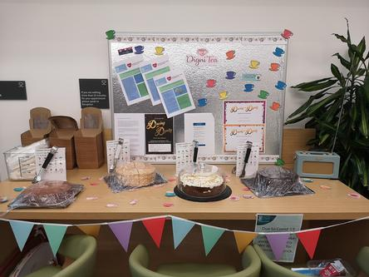

SOME EXTRACTS FROM DIGNITY ACTION DAY 2023 MEMORY BOOK
The pictures that have appeared in this report are taken from the Memory Book and the entries were chosen at random.
Brabyns House We displayed a tree decorated with hearts each representing a different aspect of dignity such as respect, communication, patience, understanding and choice. We also had daffodils, forget-me-nots and photos of residents with staff. We added a red balloon arch and all staff wore red ribbons in support
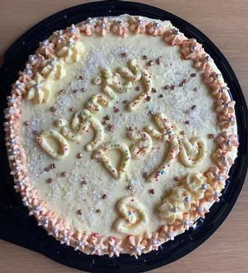

ACCOUNTS 2022-2023
National Dignity Council
Treasurer’s Report to the AGM
Statement of Accounts and Balance Sheet
for the year ended 31st March 2023
I present my report for year ended 31st March 2023. No grant income was received during the period nor any crowd funding. Website hosting remains our largest costs, but this is an essential communication channel with our champions and wider supporters. No major upgrades were required during the year, so we were able to minimise this overhead as far as possible.
Sales of badges and wristbands have been maintained and costs for postcards and badges have been in part covered by sponsorship and sales and by the NDC, an essential part of what the NDC do. Training is still a stalwart of the Charity’s income. Our on line conferences now attract a donation for a place which and will raise additional, much needed income.
I can report we are now out of deficit which is a testament to the activity of charity management and tight financial controls. A huge improvement on year ending 2022, meaning the NDC do not need to dip into reserves.
Thanks go to everyone who has been involved with our fundraising through donations, sales of badges, training provision and sponsorship. Bank statements are available monthly to all trustees and on request. Please see also the notes to the accounts for more detail.
.
Jane Finnerty
Honorary Treasurer May 2023

National Dignity Council Accounts - 31st March 2023
 | 2022-23 |  | 2021-22
INCOME
Corp Donations / training | £2,462.45 |  | £500.00
Amazon | £13.03
Donations | £485.00 |  | £2,937.73
DONR | £96.90 |  | £93.08
Sales | £3,289.16 |  | £3,116.77
Conference | £665.29
DAD - Dancing | £1,071.00 |  | £250.00
Training | £1,200.00 |  | £728.00
Just Giving | £222.16 |  | £490.54
Pay Pal | £478.76 |  | £737.39
Repayment Admin
 | £9,983.75 |  | £8,853.51
EXPENDITURE
Repayments |  |  | £28.00
PICRIGHTS |  |  | £150.00
Insurance | £307.04 |  | £299.98
Website Costs | £5230.66 |  | £5,059.27
Travel / Accom /Conf
Consultancy / secretarial
Conferences
Badges / Wrist Bands / Dos | £582.00 |  | £1,320.00
Admin travel/Stationery/ postcards/ Postage | £1,704.90 |  | £2,090.79
Miscellaneous
Honorarium | £750.00 |  | £500.00
Bank charges
Just Giving | £216.00 |  | £216.00
 | £8,790.60 |  | £9,664.04
Surplus / Deficit | £1,193.15 |  | -£810.53
BALANCE SHEET
Opening balance 01/04/22 | £8,357.44 | 01/04/2021 | £9,167.97
Surplus / Deficit | £1,193.15 |  | -£810.53
 | £9,550.59 |  | £8,357.44
Represented by
Cash at Bank | £9,550.59 |  | £8,357.44
Creditor | £0.00 |  | £0.00
Closing Balance 31/03/2023 | £9,550.59 | 31/03/2022 | £8,357.44
J A Finnerty
Treasurer

Notes to the accounts.
We ended the year to 31.03.23 up on cash at the bank, having successfully reversed the deficit of £810.53 the previous year. However, costs for merchandise such as badges and postcards have been posted after the year end [so will be in 23/24] and would have had some impact on the overall cash at bank.
Income from training sessions and an uplift in sales of the training packs is becoming an increasingly important source of the NDCs income.
Donations from Dancing for Dignity were also up on the previous year.
Income from the online conference was higher than expected and an effective way to raise future funds.

The cost of the Just Giving platform is high relative to income, however it is an important platform for NDC which trustees may wish to look at with regards to how NDC features and how we might attract more donors to the Just Giving page.. https://www.justgiving.com/nationaldignitycouncil

Amazon Smile has ceased donating to Charity.
Bank statements in hard copy form are available at any time for scrutiny by the Trustees.

Jane Finnerty May 25th 2023.

CHARITABLE AIMS AND OUR KEY WORKPLAN AIMS

Charitable Objects
- The preservation and protection of health for the public benefit by promoting best practice in standards of care, in particular the importance of dignity in care

- For the purpose of this clause ‘dignity in care’ means care, in any setting, including but not limited to hospitals, residential homes and care homes which support and promotes, but does not undermine, a person’s self-respect.

Key Workplan Aims

- Increase suite of audit tools
- Develop a training pack for Managers and Supervisors that facilitates the establishment of a Dignity Culture.
- Improve the accessibility of the website and availability of resources for Champions
- Maintain a regular newsletter
- Improve and build on links with Dignity and other networks. Including the use of the Facebook page and Discussion Forum.
- Maintain and forge robust strategic links with key stakeholders.
- Ensure the sustainability and financial probity of the Council.
- Promote National Dignity Day as a vehicle for raising the profile of the Campaign.
- Hold a National Conference

Although it did not occur in the year covered by this annual report it would be wrong not to mark the passing of our First Dignity Ambassador Sir Michael Parkinson. Sir Michael joined the campaign very early on and was proud to be associated with the concepts and principles that we were promoting. He regularly spoke on the issues and enjoyed visiting services and learning about the ways that people were putting the principles into practice. Although ill health meant that he retired as our Ambassador some time ago we are nonetheless sorry to hear of his passing and our thoughts are with his family and friends.

One of our Champions Jayne Biddsicombe recalls below a visit he made to her service.

Praise for Weston Area Health NHS Trust staff and volunteers from Dignity Ambassador Sir Michael Parkinson
In his report, Sir Michael praises the people who inspired him; highlights small steps that cost nothing, but make a real difference to people’s lives; and opens up about his own experience of the care of his mother, who had dementia.
He tells how he first met Weston nurse Jayne Biddiscombe, in September 2008, when she had signed up to the Dignity in Care campaign and become the 3,000th Dignity Champion in the country.
Jayne told him she was inspired by a heart-wrenching article in a magazine about a mother whose daughter did not receive the respect she deserved when she was in care. She wanted to make a difference and ensure that other people are treated with dignity and respect when they are at their most vulnerable.
He writes: “Since joining the campaign she’d become increasingly aware of how patients are treated in care and had been working within her hospital to highlight the importance of dignity. 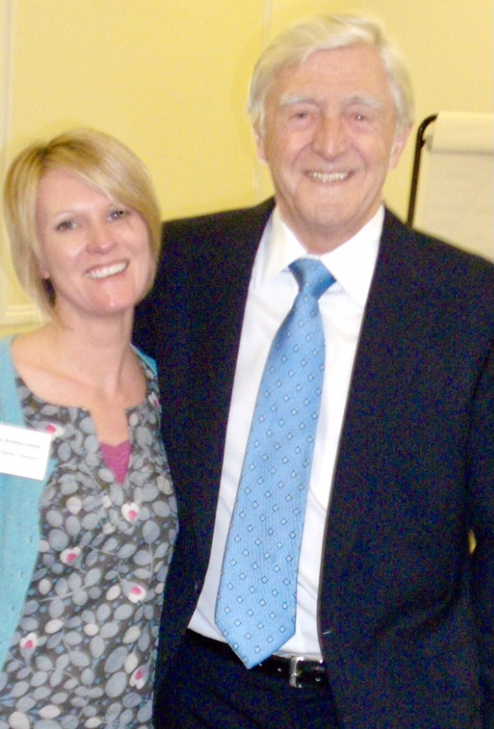
“All I can say is - watch out anyone working with Jayne who doesn’t believe dignity and compassion are vital to good care! She is a crusader with a cause, a woman with a mission. Before I knew it, she had me agreeing to come to her hospital to see their work in practice.”

Sir Michael then goes on to describe his visit to Weston General Hospital last April.
He writes: “I was taken to look around Cheddar ward and was impressed with the difference that simple changes could make. It is a single-sex ward and has a lovely sense of space and lighting.
“Many of the changes they were making were small and similar to many other hospitals around the country, such as changing curtains to ensure they close properly, having privacy signs to prevent curtains being opened on inappropriate occasions, and protecting mealtimes, so that patients are assured of being able to eat without interruption.
“I came away with the sense that they were like a family – all the staff seemed to know each other and work together – perhaps that is something other places can learn from.
“To me, the staff and volunteers at Weston hospital embodied the ethos of the Dignity in Care campaign, each person making their own contribution, however small, to make things better.”
Weston Area Health NHS Trust Chief Executive Lorene Read said: “We were delighted when Sir Michael accepted Jayne’s invitation to see us in Weston and very much enjoyed showing him our work on privacy and dignity issues.
“We are very pleased that the visit left him with such a positive view and that he has chosen to share that in his national report.”
.

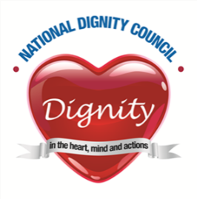

TRUSTEES AND COUNCIL MEMBERS FOR 2022-2023
TRUSTEES
Jan Burns MBE Chair retired September 2022
Chief Executive Office appointed September 2022
Lesley Flatley Chair appointed September 2022
retires September 2024
Alan Clarke MBE retires September 2023
Clare Copleston retires September 2024
Roisin Burton retires September 2023

Alex Lewney appointed March 2023
Retires September 2026
Rekha Elaswarapu retired September 2022

COUNCIL MEMBERS
Jane Finnerty. |  | Treasurer
Liz Taylor |  | Secretary /Administrator
Rekha Elaswarapu Ambassador

