Have a Go Heroes

Phase One Report

September 2010



1 Introduction

1.1 In July 2010 Tymon Kalebasiak won funding from the Department of Health through the Big Ideas Grant for his idea 'Have a Go Heroes'. An idea that was originally conceived as a project at Social Eastern Camp in Central Europe. Social Innovation Camp is a weekend long event that starts off with an open call for ideas for ways of achieving social good using the web. Have a Go Heroes was selected to compete, and the process allowed web developers, designers and business and marketing experts to come together to develop the idea into a solid project. The Big Ideas Grant was a competition created by the Department of Health and again was an open call for ideas for people with new ways of providing services to help the health service. Have a Go Heroes performed well, and secured the funding. FutureGov then became involved to look to bring the idea forward.

1.2 The idea itself is about supporting both carers and those cared for by creating a web based project that helps people who need caring perform certain tasks such as, shopping, being taken to social groups and other forms of activities. The site would mainly be targeted at older people, and those who are confident with the internet, aiming to particular benefit
older people who are isolated. There is an estimated 50,000 informal carers in the United Kingdom as of last year (a study in the British Medical Journal). These informal carers are usually family members or close friends. According to Cass Business school, a community based approach to caring for people can save up to £100 million per year. Have a Go Heroes is predominantly about creating this community support.

1.3 A project proposal was developed for project development for this first stage. The proposal outlines several areas of work, as well as understanding the social care web landscape, service and user insight, suggesting technology that could help, how such a service would look and feel like as well as thinking through possible pilot partners.

1.4 The first phase of the project began in June 2010, and has lasted around 12 weeks. The first few weeks were spent establishing the project, establishing regular contact with the Department of Health, meeting with others in the social care web space, scoping what already exists and what could be better.

1.5 During the course of the project we undertook the following research methods:

Conversations with those already working in the social care web space
(Tyze, Southwark Circle and Patient Opinion)

Spending time with reference group co-ordinators

Attending several reference group meetings to build a picture of Older
people's concerns

Facilitate a workshop with the 180 members of Bradford reference group

1.6 We also spent time talking with those interested in the project and how they may be able to become involved as the project develops. All project development has been blogged (http://haveagoheroes.wordpress.com) and interested stakeholders are often invited to comment, contribute and help shape the process.

2 Focus

2.1
"Most of the time we can all get along fine- but when we need a small bit of help it's hard to find, and harder to ask."
Participant, Reference Group

The focus of this project has been not only to create community support, but to unlock potential existing support. It seems that although care and support are in place and make a real difference to peoples’ lives the soft areas of support, such as social contact, self organising and just knowing where you can find a person to chat to can be a slightly grey area. To achieve a way of establishing and recognising support that 'works' better our focus has been to create something that is needed, useful and nifty. We know care touches lots of people's lives, so it's about finding something that people seem to value, and run in a sustainable way to add a real benefit to people's routines.

2.2 On a wider scale, the project comes at a time when volunteering and connecting local areas are high on the political agenda. In order for the Big Society to succeed communities need to become more effective, stronger and better connected to help provide the informal and social care that is often hard to reach from professional help.

"The success of the Big Society will depend of the daily decisions of
millions of people- on them giving their time, effort, even money, to
causes around them.

So government cannot remain neutral on that - it must foster and support
a new culture of voluntarism, philanthropy, social action."
David Cameron, Big Society Speech,19th July 2010

We have kept the Big Society agenda in mind through our research development, and have kept a focus on unlocking potential, as well as creating new support to try and remain as realistic as possible.

3 Problems to overcome

3.1 Digital Inclusion there is considerable work going on to bridge the gap when it comes to full digital inclusion. However, it’s also clear full inclusion is a little way off. Although Have a Go Heroes will be a web centred service we will aim to work with partners in local authorities to find alternative ways for people to reach out and get involved in the service.

3.2 Health and Safety is another significant barrier for a site that allows anyone who would like to offer or gain something from their local community post. For example, if someone offers to cook a neighbour an evening meal would that cause problems? Again, we would be interested in working through such checks with local service providers and look for ways to work through such issues.

4. Findings

4.1 The nature of care and support varies enormously

Care is a complex area, and a tricky one to divide up and analyse. However, through the project we could try and recognise what care was valued, map where support may be missing from lives, and how a project such as Have a Go Heroes could help. From discussions at reference group it seemed the main issues being addressed where with the formal aspects of care, whether social care such as the Community Links programme, or practical help, such as the Handy Persons scheme. However from one on one conversations with individuals at reference groups as well as the facilitated workshop in Bradford, it seemed that the area in which people valued most was the social contact and support that we infect informal.

"Unless you have a defined need you don't really know where to go. I don't need much help at all- but I would still like to be able to have more cups of tea and chats."

Participant, OIder People Reference Group

This shaped the project in the sense that it seemed the communities informal nature might be able to establish support in an area that although tricky to define, might be realistic to achieve and provide something different to help support existing formal care services.

4.2 What do older people value? Simple pleasures, social contact and service support

To map how Have a Go Heroes could develop into something useful we decided to ask those we wanted to help what part of their routine they valued. By asking each participant to mark the 'bright spots of their day', we left the question open enough to show whether informal social contact was something that was missing, needed or valued. We highlighted three areas that emerged:

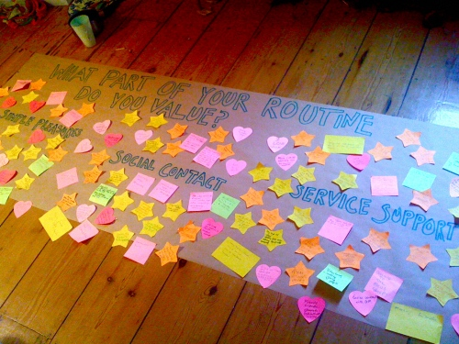

Simple Pleasures, which were often the smallest part of someone’s daily routine, such as 'the cat popping in', or simply 'waking up in the morning to a brand new day'.

Social contact, which involved meeting with those already within older people's trusted networks with contributions such as 'helping Christine with the shopping' or 'seeing my grandchildren'.

Service Support, where we could clearly see how services played their roles in making a real difference to older people's lives. Some local community groups, notably reference groups and churches appeared over and over again- valuing the opportunity to share skills and volunteer them.

Although simple pleasures noted that being along did not automatically mean a bad thing, it could be noted that many of the contributions highlighted that the 'bright points' of the day occurred when they were not alone, or felt isolated from others.

4.3 Older people want to be involved with programmes where they can contribute

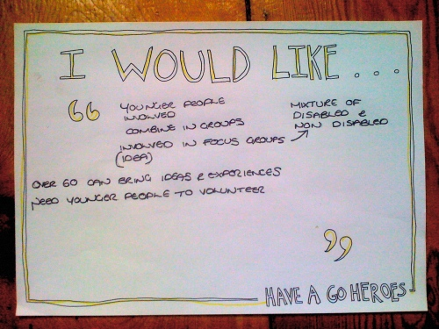

Following this, throughout the Bradford workshop and previous conversations, it seemed clear that older people valued the opportunity to contribute to programmes, rather than just receive support from them. Many of the 'I would like…' contributions when we asked participants what one thing they want for their community included more volunteering opportunities, being able to share skills or draw from experiences. The most valued service support was from programmes that required help and valued older people in return, such as the volunteering for the local church.

4.4 A willingness for older adults to become more involved with people in their local area

"When my husband came out of hospital with dementia the immediate care and support I received was fantastic- but when I was able to cope, which I was on a practical level I was, I found myself completely lost. It was very lonely."

Participant, Reference Group

As soon as conversations veered towards stronger community support and peer links were brought up time and time again. As an additional point Older people seem to recognise the importance of younger people getting involved with their local communities, and felt it was a way in which each generation could 'break down the myths' about the other .

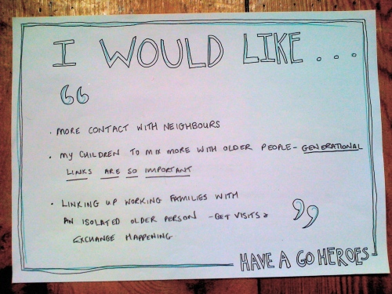

As well as our own findings research also shows this to be a promising area to peruse. A recent study highlighting that some 61% of those 65 and over saying that they would not be too busy to spend time volunteering (compared, for example, with some 60% 25- 34 year olds saying they were too busy).

5 Existing services relative to findings

5.1 iCaring a new service that aims to enable people to find care online and to make their own choices. The company, which subscribes to the digital inclusion campaign is motivated by a sense of social responsivility, helping to match carers to individuals in the need of support. From parents in need of babysitters, to the elderly.

5.2 Senior Corps a programme developed in the US have over 400,000 Americans registed that are willing to help out in their local area. Through this web based service older adults can volunteer on a wide range of projects, from community policing to even being a rented out grandparent. Have a Go Heroes could benefit in particular from exploring how the programme tackles digital exclusion.

5.3 Simpl is a new way for local authorities to bring innovation into services. The site offers a market place that asks innovators not only to answer public service problems, but help suggest ways to develop services. Simpl is a place where public sector organisations can connect with people with ideas and letting them bid with more than just cash, allowing them to offer everything from office space to service users.

5.4 we have we need is a place where relief organisations can quickly can quickly post their most urgent needs and them matched by generous donors during time of crisis. The programme allows people to easily find skills offered and calls for help through a category system. Have a Go Heroes could also use this sort of category system, particularly in our pilot stages, possibly only in one area, for example, food.

5.5 School of Everything this service believes that ‘everyone has something to learn, and everyone has something to teach.’ Like Have a Go Heroes the school aims to ‘match’ people in the local area. The school hopes to allow education to become more flexible, as well as unlocking community potential when it comes to learning.

6 Next Steps

6.1 Designing a Process On reflection, a service that invites older adults not only to ask for help (or set missions) but offer their own skills would reflect the evidence we have gathered so far. This service would ask for a postcode, and pull up all related matches, using a category or tag process. To move forward, we will need to create a visual example of how Have a Go Heroes would work and feel. This would involve bringing in a graphics designer to help us challenge our findings thus far and shape the process of the service. We will map out several options and receive service user and potential partner feedback.

6.2 Approaching Possible Partners We will be holding conversations with project partners who could help implement Have a Go Heroes on a pilot level. This may involve exploring one particular local issue at this pilot level, one being perhaps to use this service initially as a ‘community cooks’ service, as it has been reported that the service will be particularly affected by budget cuts.

6.3 Receiving Service User Feedback As well as talking through the process of how Have a Go Heroes would work we would discuss in depth what skills older people would like to offer, as well as missions they would feel comfortable sharing.

The pilot of this service will vary on possible partners, whether we focus on a specific piece of support for older people (such as community cooks) and the feedback we receive from service users. However, when reflecting on our learnings thus far, we want to create a service that is centred, but not exclusive to an online site that is simple, user friendly and easy to navigate and sign up to. We are keen to draw from a service in America called 'Senior Corps' which reflects our findings well, in that it's not just about older people receiving support from their community, but how they can contribute and become involved in it. For the ‘mission setting’ element of the service we would look to build on existing projects such as we can we need.

We aim to have a suggested pilot designed ready to be developed into a prototype and put into action with Phase Two partners.

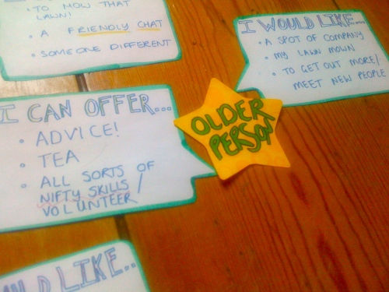

7 Phase Two: Piloting Have a Go Heroes

7.1 From this point we would begin to build the prototype of Have a Go Heroes, establishing how the service would look and feel and start managing a pilot programme on a local level. In order to continue and carry out these tasks we would need a range of stakeholders to work with:

7.1.1 A Project Team The project team would need to comprise of a service designer who can support continued service user involvement when gaining feedback from the prototype, as well as the build of the service itself; a graphics designer for the site, as well as a developer who can create the tool, a social technology specialist who can ensure the tool is fit for purpose, and a project co-ordinate who can lead the project, manage stakeholders and facilitate communications

7.1.2 A Reference Group We would be keen to create a relationship with a nearby reference group to help older people sign up to such a service, how we could make it as easy as possible, the types of 'skills' people would offer, the missions they would be comfortable setting as well as collecting continuous feedback on the development of the service itself before the pilot begins.

7.1.3 A Local Council It would be beneficial to the project if we could establish a link with a local authority, in which we could implement the service on a local level. As mentioned previously we need to consider the problem of Digital Inclusion, particularly when developing a service that aims to help older adults. We would be able to learn how they reach out to older adults in the area, and explore how Have a Go Heroes could design other ways of communication into the service. For example, flyers that social workers could hand out, or deliver to reference groups or a phone service could feed evidence back to.

7.1.4 Local Services for Older Adults For the pilot dtage of Have a Go Heroes, we would be interested in local services, such as meet ups, dance classes or reading groups offering their programmes onto the ‘we can offer’ part of the site. This would be a good way to explore the potential of local services using the site as a way of collecting local community social support and promote the service, as well as the individual older adults.

7.2 Funding The project would benefit from a local authority committing resources to support phase two and help own and shape project prototype and implementation
The project could also continue to be supported by the Department of Health- who brokered the relationship with Bradford's reference group and were a key source of sector intelligence. Other funding opportunities are yet to be explored, but could include grant funding, perhaps from NESTA's Age Unltd work, 4iP, the Young Foundation or other care charities.

8 Conclusion

8.1 Phase One of Have a Go Heroes has demonstrated that there is room for a service that does not only provide support, but allows those who are most able (older adults and younger people) to volunteer in a simple way to not only add to the community but to improve informal support networks that often seemed missing. The project would benefit from a local authority committing resources to support phase two and help own and shape project prototype and implementation

8.2 Our research identified:

The nature of care and support varies enormously

What do older people value? Simple pleasures, social contact and service support

Older people want to be involved with programmes where they can contribute

A willingness for older adults to become more involved with people in their local area

8.3 Immediate next steps include scoping the space in which they can volunteer, how they would like to help, and if they are sufficiently motivated. Once this has been undertaken and learnings have been clarified we will look towards designing a prototype of the service so we can visualise how Have a Go Heroes would work and look.

8.4 The lessons from this research have shown that, in a sense 'everyone can be a hero' that older people will be more willing to get, and stay involved, if they feel they are contributing. Phase Two of the project will examine how a service can create a space where people can swap skills, where we will look to prominent example Senior Corps from the States as a possible way forward.

8.5 Moving on from this we will look at existing examples of skills marketplaces such as we have we need, the developing Simpl service and the School of Everything.

8.6 We aim to work closely with a council to carry out a pilot stage on a local level to test process, design and gain user feedback. To do this we will concentrate on a local area, perhaps based around a local community centre or reference group. We may also concentrate on one area of support that is in particular need, such as the meals on wheels service, with the aim of rolling out to all areas of support through social contact.

http://www.big.iscene.org/
http://www.sicamp.org/social-innovation-camp-central-eastern-europe-wants-your-ideas/
http://wearefuturegov.com/2010/07/05/introducing-have-a-go-heroes/
http://www.bmj.com/content/327/7428/1388.full.pdf
http://www.cass.city.ac.uk/
http://www.conservatives.com/News/Speeches/2009/11/David_Cameron_The_Big_Society.aspx
http://www.community-links.org/
http://www.highland.gov.uk/livinghere/housing/housingfortheelderly/handypersonscheme/
http://www.londonwired.co.uk/news.php/83022-People-over-25-too-busy-to-volunteer-for-Big-Society
http://icaring.co.uk/index.php/about_us
http://www.seniorcorps.gov/
http://simpl.co/
http://wehaveweneed.org/
http://schoolofeverything.com/
http://www.thisislondon.co.uk/standard/article-23878633-30000-jobs-at-risk-as-londons-town-halls-face-pound-2bn-budget-cuts.do
http://www.seniorcorps.gov/

