January 2009 East Midlands Dignity in Care Newsletter

Happy New Year! and a very warm welcome to the first newsletter of 2009

WHAT’S NEW?

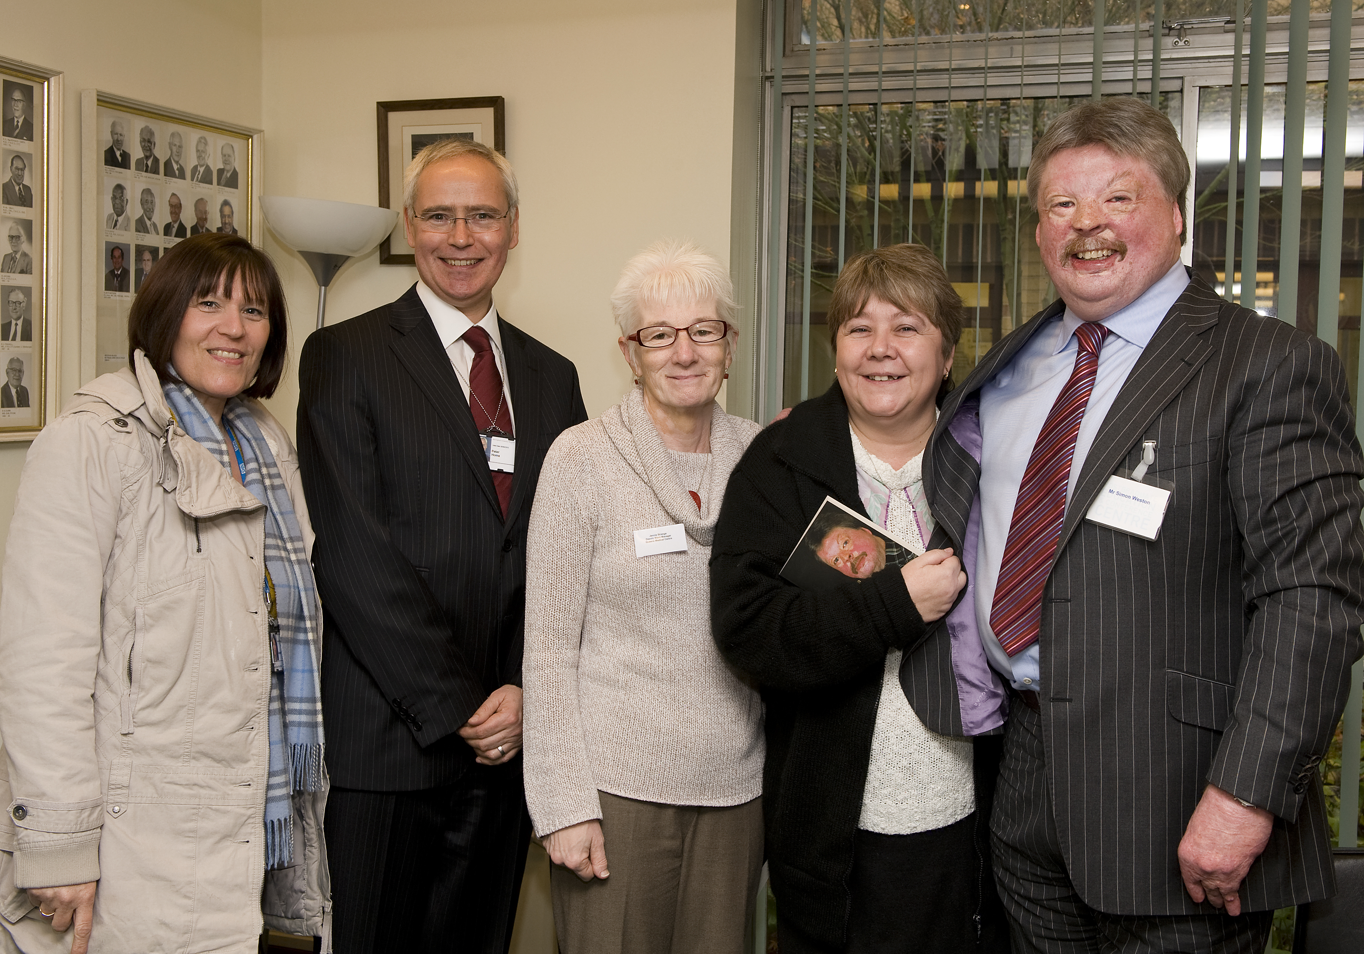
Highlights of the Nottingham Dignity in Care Conference 17th November 2009
A great day was had by all thanks to the hospitality of Nottingham University Hospitals NHS Teaching Trust and the hard work of the multi-agency planning group.

The highlight of the day was the keynote address given by Simon Weston OBE. Many individuals found his talk inspirational. Simon talked about how, when faced with huge challenges, he turned his life around and overcame obstacles by using a can do mental attitude and having the right support delivered in a dignified way.

A second visiting speaker Mick Ward described an award winning scheme in Leeds to improve dignity in care. The scheme is based on a model of social marketing and local standards. By auditing local services against dignity in care standards and raising the expectations of local citizens through marketing campaigns such as posters and radio events, health and social care partners have been able to improved dignity in care. Conference participants were given practical examples that could be replicated locally.

Conference participants also participated in a range of workshops and identified the following priorities for action:
- Development of a local network and forum to promote good practice would support the work of Dignity Champions
- Use local marketing to ensure that local citizens were better informed about what they should expect of care services and better able to make choices
- Whatever the circumstances individuals need to be given time and continuity in care
- All services should ensure that staff have appropriate interpersonal and communication skills to meet individual need

Key points that participants took away with them from the conference were:
- THINK DIGNITY
- DIGNITY and SAFEGUARDING, protecting vulnerable people is everybody’s business
- YOU and I need to challenge poor practice
- YOU and I have to be the one to change
- Take time to LISTEN
- Improve the environment
- Make your team aware of the 10 Dignity in Care Challenges

Minister for Care Services Phil Hope visits the Cynthia Spencer Hospice in Northampton on December the 18th


A visit to the Cynthia Spencer Hospice in Northampton formed part of the Minister for Care Service national dignity tour. The Minister saw the excellent work that is being undertaken to support dignity in care at the hospice, and listened to presentations describing the work of the wider palliative care team in delivering dignity in care.

The Minister also heard about the excellent work being undertaken in relation to dignity in care across the East Midlands Region. For example Nottinghamshire County Council has developed a “Commissioning for Quality Framework” to promote dignity in care homes; Leicestershire County Council and Leicester City Council are jointly leading a regional project to promote dignity in care homes; Derbyshire County PCT has commissioned a project to improve quality in nursing homes; United Lincolnshire Hospitals NHS Trust has established a Dignity in Care Committee to ensure that dignity is at the forefront of service delivery; the Alzheimer’s Society provide many good examples of social groups promoting dignity in the community; and the independent sector host dignity champions working within care homes, who are making a real practical difference.

