The National Dignity Council is the lead body in taking forward the Dignity in Care Campaign.
Our primary aim is to promote dignity across the board and raise its profile. We believe that Dignity is everyone’s business and one of the key ways in which we work is to bring together the outputs from other initiatives and ensure that learning and best practice is shared and work is collaborative and not proceeding in isolation.
Our first year of operation was very successful and we continued to sign up Dignity Champions, we now have over 49,000 individuals and organisations working actively to promote dignity in their work settings, and challenging poor practice. Our quarterly newsletter highlights the work of these champions and provides links between champions and networks. The website also highlights good practice and along with our Facebook page provides a forum for discussion of dignity issues and concerns. Our annual Dignity Action Day at the beginning of February provides a showcase for those working actively to promote Dignity as well as a chance to have fun.
In the forthcoming year we want to improve the networking of champions so that we can mobilise and cascade good practice/ sharing learning and increase access to resources and support. We will to continue to make sure that our voice is heard by the public, those who provide services and those in power, to ensure that Champions continue to feel motivated and empowered. This will inevitably mean that we will need to spend money on promoting the Ten Dignity Challenges, leaflets, dignity training tools, and marketing materials. We must continue to build the relationships with strategic partners so that scarce money is not wasted on duplication, and that synergy and connectivity is used to further the inclusion of dignity in all that we do. We also recognise the importance of engaging with young people, and we want to continue our work around intergenerational activities and building up a network of young dignity champions.
One of the ways that we are seeking to further these aims is to hold a Digni-Tea event. We want you to invite people to have a cuppa and take the opportunity to raise the profile of Dignity, both in the way you work and the importance of the Dignity challenges.
Anyone can do this, it’s easy just have a cuppa [it doesn’t have to be tea], and a cake any time in February . Health and Social Care services could invite people in to their services and showcase the ways in which they promote dignity. Champions could invite their friends and sign them up as champions and enjoy a cuppa and a chat at the same time, maybe you know someone might be lonely – go and have a cuppa with them. If anyone feels inclined to donate to the cause at the same time, this will enable us to produce a lot more resources to enable our champions to have a much louder voice and greater influence.
If you can get involved please let us know by logging your event on the Dignity map which is on the Dignity in Care website, www.dignityincare.org.uk. And if you do manage to raise any funds for the campaign please get in touch on info@nationaldignitycouncil.co.uk
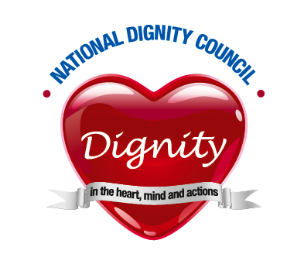Dignity in our hearts, minds and actions

