A DIGNITY CHARTER FOR DUDLEY BOROUGH

At the end of January 2016 Dudley Cil began wondering what could be done for Dignity Action Day on 1st February 2016? We decided to invite all our local MP’s and councillors to become dignity champions. Tracy went through the entire list sending emails and following up with phone calls if no response was received.
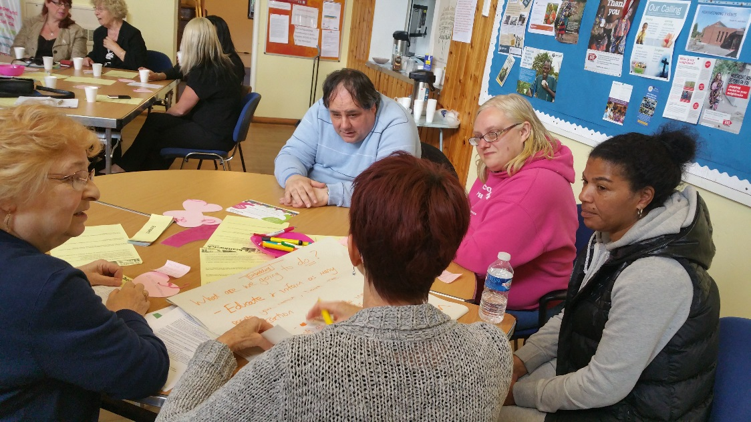
After mentioning it to Jan Burns she mentioned a dignity charter which is an agreement between local people and service providers about the standard of service in relation to dignity that can be expected. This is based upon the ten dignity principles.
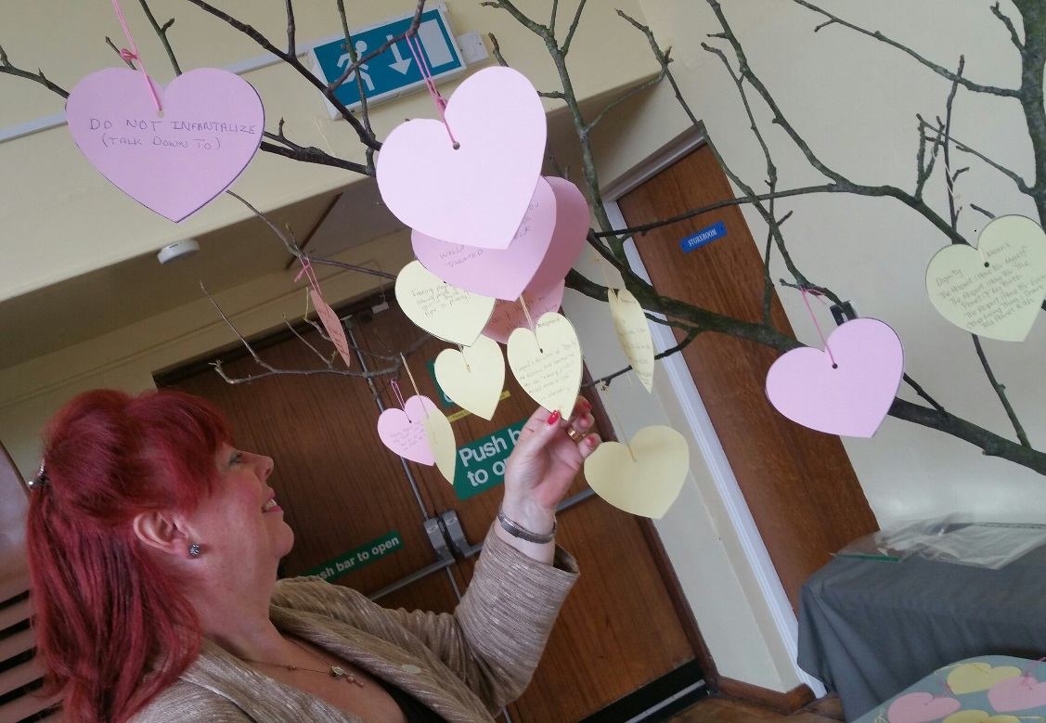
In july 2016 healthwatch Dudley ran one of their peoples network meetings on dignity at which Jan spoke and good examples were given of dignity in practice.

Following backing from council leaders and the mayor, we asked the emergency services , nhs and voluntary organisations if they would join us in signing up as dignity champions and promoting the charter. We are pleased to report that they have all done so.

We firmly believe that this campaign should be user led and include all sectors of society in our borough and we shall now be out and about with our Dignitree talking to the public about our campaign. If you are a dignity champion and would like to help us or just to find out more about what we are about and where we will be and what we will be doing and where please email dignityfordudley@yahoo.com or call Ken on 07989 515771.

