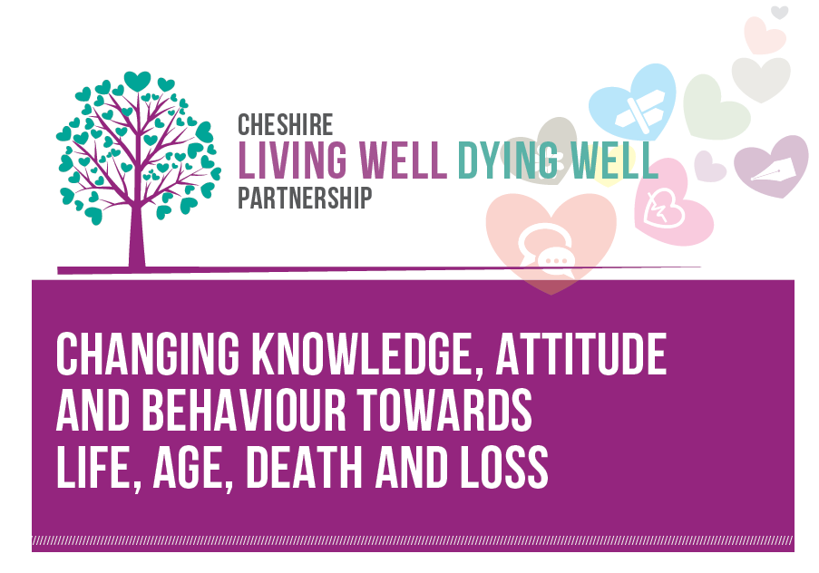

The Cheshire Living Well, Dying Well Partnership

The Cheshire Living Well, Dying Well Partnership aims to improve health and wellbeing by supporting a change in public knowledge, attitude and behaviour towards death, dying and loss and through this make living, aging, grieving and dying well the norm.

Death affects health and wellbeing in many ways. This may be as a result of aging, disability, illness, bereavement and caring for others. The Cheshire Living Well, Dying Well Partnership recognises that living well, aging well, grieving well and dying well is a public health issue as well as a health and social care issue that can be best addressed by working together.

Established in 2011, the Cheshire Living Well, Dying Well Partnership combined with Cheshire Hospices Education and the End of Life Care Service Model to form a new organisation called the End of Life Partnership in 2014. The organisation has already been awarded Pathfinder status by the Department of Health because of its pioneering public health approach to end of life experience and care across Cheshire East and Cheshire West and Chester.

Rachel Zammit, Head of Public Health and Wellbeing, Cheshire Living Well Dying Well Partnership explains:

“Our partnership includes voluntary organisations, community groups, faith groups, housing, fire and rescue services, police, local authority services, businesses and health and social care agencies. Everyone and anyone can get involved to support their family, friends, work colleagues and the wider community.”

Cheshire Living Well Dying Well Partnership encourages people of all ages to take five steps when they are healthy to help ensure that they are prepared if the unexpected happens to them or someone close. The five key steps are:

- Talking to loved one helps ensure that plans and wishes are carried out.
- Writing a will and sorting out financial matters.
- Exploring options about how and where we want to be cared for at the end of our life.
- Funeral planning will help people close to us know what type of funeral we want.
- Considering becoming an organ donor and helping someone after your death.

Cheshire Living Well, Dying Well Partnership provides a range of print and online booklets, leaflets, videos and other resources all of which aim to enable, inspire and empower people of all ages to think about, talk about and take action in relation to living, ageing, dying and grieving. For instance, The My Wishes Folder enables people to write down and store important information about your life. Keeping information in one place will make things easier for individuals and their family and friends if they are unable to look after their affairs, express interests and following their death. Plans and wishes are more likely to be carried out if we write things down.

Cheshire Living Well, Dying Well Partnership delivers training to health and social care staff and volunteers in Cheshire. For example, The Make A Difference Just By Taking course explores the benefits and barriers of talking about life, age, death and loss and how straightforward, sensitive and open approaches can create talking points with service users.

Talks, workshops and other activities, provided to members of the public of all ages via clubs, associations or other community groups, play an important role in removing barriers and explaining the benefits of being more open about death. For example, the Wills Workshop is a two-hour interactive and informal event that focuses on wills, inheritance tax and includes a question and answer session with a solicitor. The Crafting Memories sessions use creative expression to encourage people to think about, talk about and take action in relation to life, age, death and loss. The sessions bring together people of different backgrounds and generations in a relationship centred way to encourage conversation.

Rachel Zammit, Head of Public Health and Wellbeing, End of Life Partnership explains:

“Many people are unprepared for their own or their loved ones death: wills have not been written and end of life wishes not discussed. We know that death is not an easy thing to discuss but peace of mind, quality of care and living well depend on us being able to talk about it openly and sensitively throughout our life with those close to us. We work with any organisation and community group, however large or small in Cheshire.”

Add website: www.cheshirelivingwelldyingwell.org.uk

