Dignity in our hearts, minds and actions 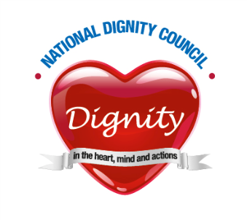
The National Dignity Council Meeting
Notes of meeting held
16th November 2015
At the Offices of Skills for Care
Following the Annual General meeting
Present: six members of Council

Apologies: received from 8 members of Council

Notes of last meeting
These were accepted without amendment.
Actions from last meeting.
The meeting noted that:-
- The Charity application has been submitted to The Commission, with the Trustees being, Jan Burns, Liz Taylor, Frank Ursell, Jane Finnerty, Rekha Elawasparu, and Jean Hardiman Smith.
- It has been agreed that we can keep the remaining part of the grant from DoH, subject to certain conditions relating to its expenditure.
Dignity Action Day
Conference
- The flyer is ready, and will be circulated after the meeting. Sally Greengross has very generously agreed to be our keynote speaker. Other speakers are also in the pipeline and the final programme should be available early next month.
- Exhibitors – potential exhibitors are being contacted regarding both exhibiting and sponsorship.

Dignity Action day itself.

- The meeting noted the need to keep it live and ensure that it is mentioned everywhere we can. There is also a need to make sure that people understand that their event doesn’t need to be on the 1st, it’s about using that as a focus and making sure people put their events on the map; and in any newsletters they contribute to,

Matters arising from AGM

The way forward and plans for the future.

Pass it On Funding Bid
- It was suggested that if it were not successful it might be worth pulling it apart, and looking at what can be achieved through other funding options. For example using hospitals and our links there as a way of making better contact with the public. .
Dignity Awards
- The meeting discussed ways in which Council can recognise the work that Champions are doing, perhaps through an award. It was recognised that there are so many awards already out there and we need to be realistic. Perhaps a better option would be to choose from those that have won elsewhere. Choosing some key awards givers and then choose a winner of winners.
- It was agreed that there was a need for a project plan, and someone to manage this through to conclusion.
- The Council is interested in hearing from anyone who is interested in doing this piece of work.

Intergenerational Activity. And Engaging with Children and Young People
- The meeting agreed that we had not moved as far forward with this as we had hoped. Some of the issues were around the fact that the concept of dignity is one which is difficult for children to grasp, and it may be that we need to think of a different way of getting them involved. For example the concept of kindness is something that they do understand. It would be good if we could get children involved in expressing the Dos in a more comprehensible way for them.
- It was agreed that this should be explored locally through existing contacts.

Standards
- Following emails to the website requesting standards so that organisations could judge the training they were developing around dignity against some common and agreed Training standards –
- The importance of linking with the Care Certificate and looking at outcomes was recognised.
- There is a need to scope the project and pull together what is already out there. This could then be used to evidence, the effectiveness of training. It needs to be a paid piece of work and needs to bear in mind the way in which it can be used to influence a wider audience.
- The meeting recognised that if you have standards they need to be time limited. The best way forward would be to have terms and conditions that people sign up to.
- Dignity should underpin- run through everything that’s happening.

Finally
- It was concluded that a project sponsors for each item for the future, so that we could see things through.
Date of Next meeting
Given the changes to the constitution the next full meeting will be at the Annual General Meeting in September 2016
Dates of the Trustee meetings to be agreed.

