Dignity Champion Certificate of Commitment
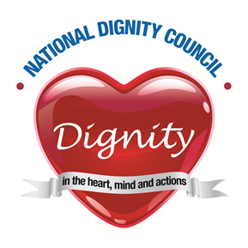

___Delete and insert own name___
Pledges to:

- Uphold the Ten Dignity do’s
- Stand up and challenge disrespectful behaviour rather than just tolerate it
- Act as a good role model by treating other people with respect particularly those who
are less able to stand up for themselves
- Speak up about dignity to improve the way that services are organised and delivered
- Influence and inform colleagues
- Listen to and understand the views and experiences of citizens
Jan Burns - Chairman National Dignity Council

